Submitted by: Dr. Muhammad Rafiq

**Research study on**

**The Health and Wealth Impacts of Air Pollution in Peshawar**

Second Draft

**Assessing the Contextual Causal Impacts of Air Pollution on Public Health in Peshawar, and Identifying the Avenues for Multi-Faceted Approaches for Healthier Air Quality in Peshawar**

**Submitted by**

**Dr. Muhammad Rafiq**

# Table of Contents

|  |  |  |
| --- | --- | --- |
| **SNO** | **Contents** | **Page No** |
| 1 | Executive Summary | 5 |
| 2 | Overview, & Objectives | 8 |
| 3 | Literature Review | 9 |
| 4 | Methodology | 12 |
| 5 | Qualitative Analysis | 19 |
| 6 | Quantitative Analysis | 24 |
| 7 | Synthesis and Policy-led Interventions | 31 |
| 8 | Annexures | 38 |

**ACRONYMS**

|  |  |
| --- | --- |
| ADHD | Attention deficit hyperactive disorders |
| AQI | Air Quality Index |
| BHU | Basic Health Units |
| BKMC | Bacha Khan Medical College |
| BRT | Bus Rapid Transit |
| COI | Cost of Illness |
| COPD | Chronic Obstructive Pulmonary Disease |
| DALY | Disability-Adjusted Life Year |
| DHIS | District Health Information System |
| DM | Diabetes Mellitus |
| DW | Disability Weight |
| EPA | Environmental Protection Agency |
| GBD | Global Burden of Disease |
| GDP | Gross Domestic Product |
| GDPPC | Gross Domestic Product per Capita |
| GIS | Geographic Information System |
| GNI | Gross National Income |
| GSP | Gross State Product |
| HCA | Human Capital Approach |
| HD | Health Department |
| HIMS | Health Information Management System |
| HMC | Hayatabad Medical Complex |
| IDSRS | Integrated Disease Surveillance and Response System |
| IERB | Institutional Ethics Review Board |
| JICA | Japan International Cooperation Agency |
| KII | Key Informant Interviews |
| KP | Khyber Pakhtunkhwa |
| KTH | Khyber Teaching Hospital |
| LE | Life Expectancy |
| LRH | Lady Reading Hospital |
| LRI | Lower Respiratory Infections |
| MMR | Measles, Mumps, Rubella |
| MOVD | Monetary Value of DALY’s |
| NCAP | National Clean Air Policy |
| NEQS | National Environmental Quality Standards |
| NWGH | Northwest General Hospital |
| PCAA | Peshawar Clean Air Alliance |
| PCHE | Per Capital Health Expenditure |
| PEQS | Provincial Environmental Quality Standards |
| PESCO, | Peshawar Electric Supply Company |
| PHED, | Public Health Engineering Department |
| PIMS | Pakistan Institute of Medical Sciences |
| PM10 | Particulate Matter 10 |
| PM2 | Particulate Matter 2 |
| SDI | Socio-Demographic Index |
| SEED | Sustainable Energy and Economic Development |
| T2D, | Type 2 Diabetes |
| URI | Upper Respiratory Infection |
| UV | Ultraviolet |
| VETS | Vehicular Emission Testing Stations |
| VSL | Value of Statistical Life |
| WSSC, | Water and Sanitation Services Company |
| WTP | Willingness to Pay |
| YLD | Years of Living with Disability |
| YLL | Years of Life Lost |

# Executive Summary

Pakistan's Sustainable Energy and Economic Development (SEED) program, particularly focused on the Khyber Pakhtunkhwa (KP) region, fosters provincial economic growth while promoting sustainable energy practices. With a keen focus on addressing climate change's impacts on human health and environmental well-being, SEED collaborates closely with the Peshawar Clean Air Alliance (PCAA) to tackle the pressing issue of air pollution. The present research study is pivotal to SEED's commitment to informed policymaking. It seeks to correlate air quality levels measured by installed monitors with specific health conditions observed in hospital patient data. Additionally, it aims to assess whether poor air quality directly causes health issues, particularly by examining differential impacts on vulnerable population segments such as the elderly, women, and children.

A Mixed Methods Research (MMR) approach has been utilized to comprehensively investigate the research problems surrounding air pollution and its impact on public health. This methodology seamlessly integrates quantitative and qualitative components, allowing for a more nuanced understanding of the issues. Drawing upon primary documents and data sources, an explanatory sequential mixed methods design was employed for data collection, analysis, and integration. Data regarding the health outcomes stemming from acute and chronic conditions linked to air pollution was gathered from prominent tertiary hospitals including Hayatabad Medical Complex(HMC), Khyber Teaching Hospital (KTH), Lady Reading Hospital (LRH), and Northwest General Hospitals (NWGH). A comprehensive list of all medical facilities in the district of Peshawar can be found in Annex 1. Hospital datasets encompassing in-patient, outpatient, hospitalization, mortality, and morbidity cases related to six prevalent air-borne diseases, namely ischemic heart disease, stroke, lower respiratory infections, lung cancer, type 2 diabetes, and chronic obstructive pulmonary disease (COPD), were procured. The selection of these diseases is according to the criteria laid down by the World Health Organization (WHO), and existing health impact assessment studies[1]. Nonetheless, the quality of the obtained datasets fell short of expectations.

Air quality data for 2022-23 was collected from various sources including the US Consulate Peshawar Air quality monitors, AirNow, IQAir, and PCAA. These sources monitor real-time air pollutants from stations located across hotspots in the district of Peshawar, covering areas such as Hayatabad, Tehkal, Warsak Road, GT Road, and Dalazak Road. Selection of air pollutants focused on those exceeding daily and annual average levels established in the National Environmental Quality Standards (NEQS)/PEQS. To prevent duplication, only PM2.5 was included as PM10 encompasses PM2.5. This approach aligns with previous health impact assessment studies on air pollution.

Health impact assessments regarding the burdens imposed by air pollution were conducted using suitable correlation and estimation methods. This study has quantified Disability Adjusted Life Years (DALYs) resulting from ambient air pollution. The economic costs associated with air pollution were determined using the monetary Value of Disability Adjusted Life Years (DALYs) (MOVD). This methodology is rooted in the "Human Capital Approach" (HCA). The gathered datasets on Air Pollution and Health Information Management Systems (HIMS) were subjected to thorough analysis utilizing correlation tests, including the Pearson test for continuous variables and the Spearman rank test for nominal variables. Additionally, Likelihood ratio Chi2 test statistics were employed to examine the distribution of health outcome prevalence and incidence concerning age, gender, and location.

One of the study objectives is to calculate gender and disease-specific Disability Adjusted Life Years (DALYs) for District Peshawar. The total health impact is estimated at 99,299 DALYs. In simple terms, One DALY represents the loss of the equivalent of one year of full health due to air pollution. The total economic impact amounts to 154 million USD or roughly 43 billion PKR, equivalent to approximately 2 percent of the Gross State Product (GSP) of District Peshawar. Gender-specific calculations reveal losses of 126 million USD (approximately 36 billion PKR) for females and 179 million USD (approximately 50 billion PKR) for males. Furthermore, the most substantial disease-specific impacts are observed in ischemic heart disease and Respiratory Infectious diseases. These findings underscore the urgent need for targeted interventions to mitigate air pollution and alleviate its economic and health burdens in the region.

To effectively address the health repercussions of air pollution, a comprehensive strategy encompassing legislative actions, research initiatives, public awareness campaigns, and healthcare system enhancements is imperative. Mitigative measures should focus on promoting cleaner fuel, and technology adoption to improve air quality, along with robust data management systems to monitor pollution levels and patient data. Creating green urban spaces can aid in air purification, while public education programs via social and print media, as well as engagement with religious leaders, can raise awareness about the health hazards of pollution. Sustainable urban planning practices, including prioritizing pedestrian-friendly areas and efficient public transportation systems, are crucial, alongside stringent enforcement of environmental regulations in industries. Shifting towards market-based incentives for greener technologies is recommended. Increased investment in healthcare infrastructure is vital, especially in pollution-prone urban areas, where current per capita health expenditure falls below WHO recommendations. Moreover, fostering global collaboration to address cross-border pollution issues and engaging local communities in solution-finding processes can yield culturally sensitive and sustainable outcomes.

# Overview of the Project

The SEED program in Khyber Pakhtunkhwa, Pakistan, focuses on economic development and sustainable energy while addressing air pollution through a partnership with Peshawar Clean Air Alliance. Among the notable initiatives already underway, the establishment of an air quality monitoring network stands out, alongside the commencement of a thorough assessment of the current air pollution landscape.

Presently, a research study has been completed on air pollution's health and economic impacts, inspired by Peshawar's high pollution rankings, to inform policymaking and improve residents' well-being. This study magnifies the health and economic impacts of air pollution in Peshawar. The impetus for this research stems from the Global Air Quality Report (2021), which has notably ranked Peshawar as the third most polluted city in Pakistan and the ninth most polluted city globally.

The current research study represents an indispensable component of SEED's commitment to informed policymaking. Moreover, it assumes a key role in the broader mission of SEED—to enhance air quality and improve the overall well-being of the residents of Peshawar. Through these combined efforts, SEED and PCAA aspire to contribute meaningfully to sustainable development, environmental conservation, and the creation of a healthier living environment for the community.

# 2. Major Objectives of the Project

The main objectives of this study are as follows:

* To determine the correlation between air quality levels (measured by the installed air quality monitors) and the incidence of specific health conditions observed in hospital patient data.
* To assess whether poor air quality causes health issues, assess if the impacts differ for vulnerable population segments such as elderly people, women, and children.
* To provide evidence-based insights that can inform policy decisions aimed at improving air quality and public health in the city.

# 3. Literature Review/Desk Review

For the ongoing study, we have meticulously conducted an in-depth and purposeful review of the recent literature on health and economic impact analysis. In addition to thoroughly examining relevant health and economic literature, we have also exhaustively reviewed all available research on the dynamics concerning the state of air pollution in Peshawar.

The health impacts of air pollution are a pressing global challenge, and continued research and policy efforts are essential to mitigate these effects and protect public health. The synthesis of knowledge presented in this literature review provides a foundational base for the present research. However, most of the relevant studies relied on quantitative assessment, and the incorporation of qualitative assessment improved upon previous assessments. Therefore, the proposed methodology can provide breadth and depth for more cohesive and conducive policy inputs.

The findings and insights derived from this comprehensive literature review are succinctly summarized in the subsequent table.

*Table 1. Summary Table of the Literature Reviewed.*

|  |  |  |  |  |
| --- | --- | --- | --- | --- |
| Author (Year) | Short Title | Design | Major Variables | Major Findings |
| Syuhada, G. (2023) | Impacts of Air Pollution on Health in Jakarta | Quantitative design,  Assessment of Health & Economic Burden, COI, VSL, cross-sectional data | PM2.5, O3, infant mortality, birth weight, stunting, COPD | Positive relationship with mortality, cardiovascular diseases, and adverse health outcomes,  PM2.5 and O3 correlate with over 10,000 annual mortalities, 7,000 adverse health outcomes, and a USD 2943.4 million economic burden. |
| Abbasi-Kangevari et. Al. (2023) | Effect of air pollution on disease burden (North Africa & ME) | Quantitative design, mortality, DALYs, life expectancy, Summary Exposure Value (SEV)/RR prevalence of exposure, longitudinal data | PM2.5 (both ambient & HH), O3, Socio-demographic Index (SDI) | Higher DALY rates in Afghanistan, Yemen, and Egypt due to air pollution, with potential life expectancy gains of 1 to 6 years with reduced pollution.  Increase in life expectancy if air pollution level reduced to WHO standards. |
| Chatterjee et al. (2023) | Source Contributions to Fine PM2.5 and Attributable Mortality (India & surrounding countries) | Quantitative design, cause-specific mortality rate, longitudinal data | PM2.5 (both ambient & HH), | Continuous increase (1.02 million deaths) attributed to air pollution,  Leading cause-specific mortality rates were HH combustion (28%), industry (15%), and power sector (12%) |
| Health Effects Institute [HEI] (2022) | Air Quality and Health in Cities: Global Air Report | Quantitative design, morbidity, mortality, longitudinal data | PM2.5, NO, ischemic heart disease, lung cancer, COPD, lower respiratory infections (pneumonia), stroke, type 2 diabetes, and adverse birth outcomes | South Asia with highest average exposure to PM and increased mortality rate per 100,000.  Increased traffic has positive link with adverse health outcomes in Asian region. |
| Zhang et al. (2022) | Health Impact and Economic Loss Assessment of O3 and PM2.5 (China) | Quantitative design, variation in population exposure, mortality rate, population census longitudinal data, log-linear exposure-response function (RR), COI approach | PM2.5, O3, cardiovascular & respiratory diseases | Increased exposure risk of cardiovascular and respiratory deaths,  Economic burden (COI) of CNY 3.5 billion for 2020. |
| Liu et al. (2021) | Impact of Air Pollution on Residents' Medical Expenses: Survey Data of 122 Cities in China | Quantitative design, Regression (IV), cross-sectional survey data | AQI, cardiovascular & respiratory diseases, medical expenses, demographics | Increased in medical exp. Related to cardiovascular and respiratory diseases from 3% to 42% with poor AQI. |
| Panezai et al. (2021)  Rafiq, M.* | Quantifying the health and wealth benefits of reducing point source pollution: Sugar industry in Pakistan | Quantitative design, cross-sectional HH data, COI, logistic regression | PM2.5, PM10, NO, CO, SO, ARI, URI, LRI, demographics | Economic cost of USD 0.27 million per years for Mardan. |
| Errigo et al. (2020) | Human Health and Economic Costs of Air Pollution in Utah: An Expert Assessment | MMR, Exper-assessment approach (23 regional air pollution experts) on DALYs, pollutant-specific diseases, direct & indirect health costs, summary stat. | PM2.5, O3, NO, CO, SO, air-borne diseases | Decreased life expectancy by 1.1 to 3.6 years.  Economic loss of USD 0.75 billion to 3.3 billion in Utah state. |
| WHO (2020) | WHO methods for Global Burden of disease 2000-2019 | Quantitative design, longitudinal data, DALYs | Communicable, non-communicable diseases, & injuries, age, sex | Exposure to PM pollution has the largest and strong relationships with ischemic heart disease, Stroke, Lung Cancer, Diabetes Mellitus, COPD, URI, and LRI. |
| GBD 2019 Risk Factors Collaborators* (2020) | Global burden of 87 risk factors in 204 countries and territories, 1990–2019 | Quantitative design, longitudinal data, DALYs, RR | 87 risks, Socio-demographic Index (SDI), |
| Robinson et al. (2019) | Valuing Mortality Risk Reductions in Global Benefit-Cost Analysis | Quantitative design, longitudinal data, VSL (WTP), value of mortality risk reductions | Health indicators, macroeconomic (GNI) | Strong methodological base for VSL application in the health sector. |
| PCAA-SEED (2021) | Status of Air Pollution in Peshawar | Review of the Secondary data | Apportionment Study | PM2.5 level in Peshawar ranges from 61.4 to 80.1 micrograms/m3, exceeds national standards by 4-5 times and WHO standards by 12-16 times.  Major pollution contributor is transport emissions. |

# 4. Methodology and Study Design

A Mixed Methods Research (MMR) methodology has been used by integrating both the quantitative and qualitative components of the research and drawing inferences on the combined strengths to better understand the research problems under study (Creswell & Clark, 2018). In more simplistic terms, Mixed Methods Research (MMR) combines numbers and stories to learn more about a topic. In studying air pollution and its health effects, researchers use both numbers (like statistics and measurements) and stories (like people's experiences) to understand the problem better. This helps get a full picture of what's happening and why. They do this by collecting, analyzing, and putting together data from different sources, like surveys and interviews, to draw meaningful conclusions.

The basic methodological process of the explanatory sequential mixed methods design is shown in Figure 1.

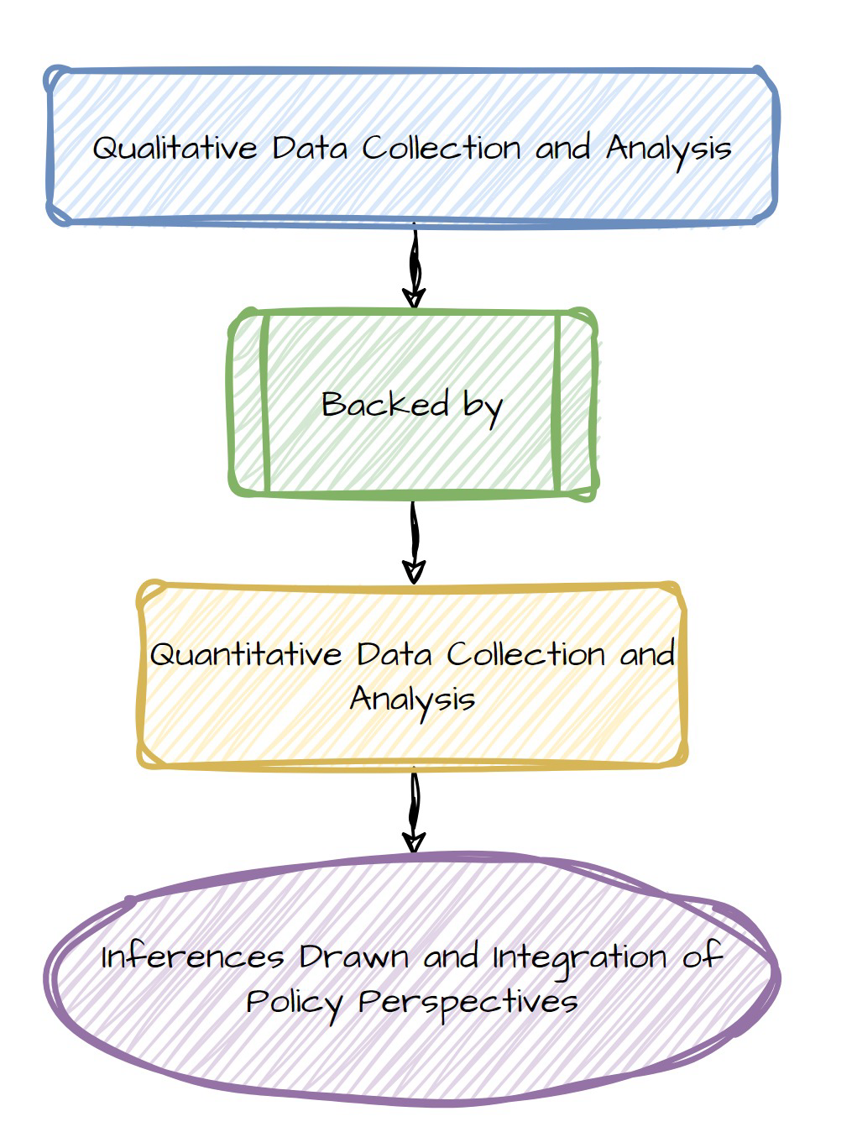

*Figure 1: The Explanatory Sequential Mixed Methods Design ((Creswell & Clark, 2018))*

## 4.1. Overview of Data Collection Strategy

A two-phase data collection strategy was implemented to gather a) qualitative data, involving Key Informant Interviews (KIIs), and b) quantitative data collection including air quality data comprising weather patterns and air pollutants data, notably Particulate Matter such as PM2.5, along with other available pollutants. The air pollution data was sourced from the PCAA monitors situated in the study areas. Health data and patient-related information linked to air pollution, encompassing adverse health outcomes, case numbers, and associated costs, were obtained from hospital databases. Demographic details such as age, gender, and location were also included in the data collection process.

For qualitative data, several in-depth interviews were carried out to understand the thorough perspective of the interviewees regarding the subject matter. The interview guideline was developed for this study to collect relevant data. The KIIs also tried to shed some light on the average cost of diseases related to air pollution, and existing institutional gaps towards addressing air pollution and public health.

## 4.2. Data Description and Collection

### 4.2.1 Exposure Data

Air quality data of the pollutants for 2022-23 was gathered from the US Consulate Peshawar Air quality monitors, and AirNow, IQAir, PCAA, etc. which observe real-time air pollutants data from monitoring stations installed throughout hotspots of district Peshawar including Hayatabad areas, Tehkal, Warsak road, GT road, and Dalazak road.

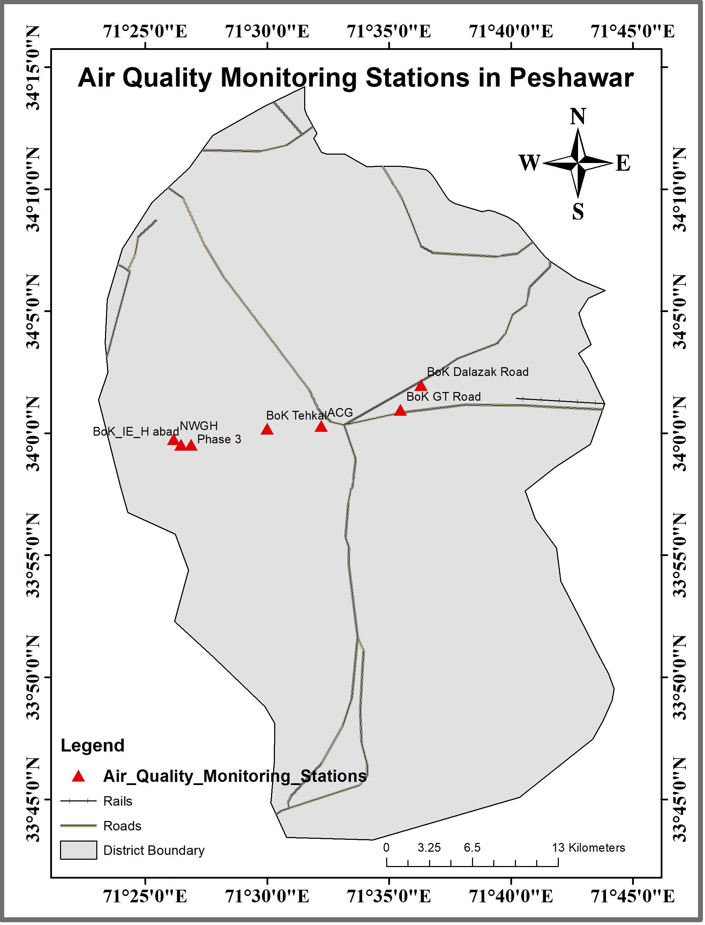

*Figure 2: Air Quality Monitoring Stations-Peshawar*

The selection of air pollutants is based on health-damaging effects that exceed daily and annual average levels set in the National Environmental Quality Standards (NEQS)/PEQS. To avoid double counting, only PM2.5 is included since the PM10 includes PM2.5. This is consistent with the previous estimation of health impact assessment studies related to air pollution[2].

Additionally, the annual average exposures to the air pollutants (that is, the concentrations- a population in a specific area is more likely to be exposed to in one year), the concentrations in each grid cell with the number of people living within each block to produce a population-weighted annual average concentration. Population-weighted annual average concentrations are better estimates of the population exposures than, for example, simple averages across monitors because they give greater weight to the pollutant concentrations experienced where most people live.

The population-weighted air pollutant concentrations represent annual averages across an entire city. They include the considerably higher concentrations that may be observed day to day or in certain seasons, especially around major pollution sources.

This study has utilized the same procedure adopted by related studies; Satellite data are more reliable in estimating long-term than short-term trends. Although short-term exposure spikes can affect health, it is long-term exposures that contribute most to the burden of disease and mortality from air pollution (Health Effects Institute, 2022).

### 4.2.2 Health Data

The data for the health outcomes of both acute and chronic health conditions attributable to air pollution was obtained from tertiary hospitals such as HMC, KTH, LRH, and Northwest hospitals. However, a complete list of all the medical hospitals of district Peshawar can be found in Annex 1. The hospital datasets of in-patient, outpatient, hospitalization, mortality, and morbidity associated with the six air-borne diseases (i.e., ischemic heart disease, stroke, lower respiratory infections, lung cancer, type 2 diabetes, and chronic obstructive pulmonary disease (COPD)) were obtained. The selection of air-borne diseases is consistent with the health impact assessment studies[3]. However, the quality of the data sets was not according to our expectations. Further, the study tried to collect first-hand information on the mitigation costs including direct monetary medical costs associated with air-borne diseases calculated in consultation with disease-specific medical experts. The demographic data such as age, gender, and location were obtained from the hospital patient datasets. However, as explained earlier the quality of the data sets isn’t very good.

### 4.2.3 Limitations/Data Gaps in the Hospitals’ Health Data

During the quantitative health data collection from the sampled tertiary hospitals (NWGH, RMI, HMC, KTH, and LRH), the data collection team followed the process of the Institutional Research and Ethical Board (IREB) procedure and provided the application for the provision of the health data accompanied by a certificate of ethical approval. In the project timeline, only NWGH, KTH, and LRH have provided health data. The HMIS of the NWGH was updated and has good quality health data but the sample size was small for the study period, while the nature of the recorded health data in the public sector tertiary hospitals lack analytical depth. There is no disease-specific outpatient health data and were extracted from the inpatient health records which significantly limited the application of a more robust analysis. Such data gaps need re-evaluation and upgradation of the HMIS particularly in the public tertiary hospitals.

*Table 2. List and type of Indicators (Variables) for Data Collection*

|  |  |  |  |
| --- | --- | --- | --- |
| Indicators Group | Indicators | Description | Type |
| Air Quality | (PM10, PM2.5, O3, N02, SO2) | Pollutant levels data in micrograms/m3 | Continuous indicators |
| Health Outcomes  (Air-borne Diseases) | Upper & Lower respiratory infections (URI& LRI)  Ischemic heart disease  Type 2 diabetes  Strock  Trachea, Bronchial cancers  Chronic Obstructive pulmonary disease (COPD) | Morbidity  Mortality  Days of hospitalisation  Number of outpatient and inpatients in the hospital’s database and/or archives, | Discrete indicators |
| Demographics | Age  Gender  Location | Age of the patient  The gender of the patient  Location or area | Discrete and categorical indicators |
| Mitigation Costs  Economic Costs | Medical costs | It includes direct monetary medical costs associated with a particular disease | Continuous indicator |

## 4.3. Data Analysis

The health impact assessment or health burdens attributable to air pollution have been calculated using appropriate estimation techniques. This study has computed Disability Adjusted Life Years (DALYs) caused by ambient air Disability-adjusted life years. (DALYs) measures the number of years lost due to ill health, disability, or early death.

### 4.3.2. Economic Assessment/Estimation of Economic Burden

The economic costs or economic burdens attributable to air pollution are calculated using the monetary Value of DALYs (MOVD).

This technique is based on an approach called the “Human Capital Approach” (HCA) initially suggested by Weisbord (1961). According to Weisbord, ‘The present value of a man at any given age may be defined operationally as the discounted expected future earnings stream net of his consumption ...’ (p.427).

The monetary value of DALYs lost from each of the 157 diseases is equal to the number of DALYs lost from each disease (DALYi = 1, γ) multiplied by GDP per capita (GDPPC) minus Per Capital Health Expenditure (PCHE)[4], denoted algebraically as :

MOVD = DALY (GDPPC- PCHE) (1)

To estimate costs incurred due to attributable diseases, the required economic indicators are listed in Table.’

*Table 3. List of Indicators for Economic Impact Estimation.*

|  |  |
| --- | --- |
| Indicators | Amount in USD |
| Per Capita Health Expenditure | $37 |
| GDP (2022) | $374.7 |
| GDPPC (2022) | $1,589.9 |
| (GDPPC- PCHE) | 1,552.9 |

*Source: World Bank & Ministry of Finance, GoP*

### 4.3.3. Estimation of Disability-Adjusted Life Years (DALY)

The Disability Adjusted Life Years (DALY) is a summary measure that combines time lived in states of less-than-optimal health (disability) or time lost through premature death. One DALY can be thought of as one lost year of ‘healthy’ life and the measured disease burden is the gap between a population’s health status and that of a normative reference population.

DALYs for a specific cause are calculated as the sum of the YLLs from that cause and the YLDs for people living in states of less than good health resulting from the specific cause:

DALY *(c, s, a, t)* = YLL *(c, s, a, t)* + YLD *(c, s, a, t)* for given cause c, age a, sex s and year t (4)

The YLLs for a cause are essentially calculated as the number of cause-specific deaths multiplied by a loss function specifying the years lost for deaths as a function of the age at which death occurs.

The YLLs are:

YLL *(c, s, a, t)* = N *(c, s, a, t)* x LE *(s, a)* (5)

where: N *(c, s, a, t)* is the number of deaths due to the cause c for the given age and sex s, in year t.

LE *(s, a)* is a standard loss function specifying years of life lost for death at the age for sex s, or simply life expectancy.

To estimate YLDs for a particular cause in a particular period, the number of incident cases in that period is multiplied by the average duration of the disease and a weight factor that reflects the severity of the disease on a scale from 0 (perfect health) to 1 (dead):

YLD (c, s, a, t) = I (c, s, a, t) x DW (c, s, a) x L (c, s, a, t) (6)

where:

I (c, s, a, t) = number of incident cases for cause c, age a, and sex s

DW (c, s, a) = disability weight for cause c, age a and sex s

L (c, s, a, t) = average duration of the case until remission or death (years)

Nonetheless, the World Health Organization (WHO) and Global Burden of Disease (GBD) also report Disease-specific and cause-specific DALYS for the member countries.[5] The present study will also try to make use of these datasets.

### 4.3.4. Statistical Analysis (Correlation, Variation)

The collected Air Pollution, and HIMS data sets have been analyzed through correlation tests i.e., Pearson test for continuous variables, Spearman rank tests, and Likelihood ratio chi2 test statistics for the nominal variables. The likelihood ratio Chi2 test statistic helped analyze the distribution of the prevalence and incidence of health outcomes by age, gender, and location.

### 4.3.5 Qualitative Analysis

Qualitative data is examined using Thematic analysis, which is a widely used qualitative data analysis technique that involves identifying, analyzing, and reporting patterns or themes within the data. It provides a systematic approach to organizing and interpreting qualitative information, making it a valuable method for uncovering rich insights from interview transcripts, focus groups, or any other narrative data.

### 4.3.6 Ethical Considerations

**A**dhering to ethical guidelines and regulations governing research involving health data and patient privacy is an important component of research work and policy analysis. The research team followed the ethical guidelines and ensured the patients’ data confidentiality and rights were protected throughout the study. The data collection tools and guidelines were approved by the IERB of all the hospitals and universities. See annexure.

# 5. Qualitative Analysis

This section draws upon the insights from Key Informant Interviews (KIIs) to offer a comprehensive overview of how air pollution affects public health, highlighting the most impacted gender and age demographics, providing an estimate of the average costs involved, identifying gaps in research and policy, and suggesting context-specific policy interventions that could mitigate the health impacts of air pollution in Peshawar. For this purpose, a qualitative research approach- purposive sampling was utilized. The reason for opting for purposive sampling was to get insights from the concerned experts. A structured interview guideline was developed, to obtain a thorough grasp of the relevant interviewee’s viewpoints on the subject, through face-to-face interaction by in-depth interviews. Several in-depth interviews were conducted, to understand the thorough perspective of the interviewees regarding the subject matter.

Additionally, the collected data (Key Individual Interviews) endeavored to contribute towards a) Obj. 2, that is, to assess the air pollution detrimental impacts on human health, irrespective of age and gender. It also evaluates the required collaboration needed with other government departments in the future; and b) Obj. 3, by providing an evidence-based multi-sectoral approach for policy advocacy towards healthy air quality levels vis-à-vis improved public health in Peshawar. The KIIs also identified an average cost estimation of a disease related to air pollution, and existing institutional gaps towards addressing air pollution and public health.

Following a comprehensive stakeholder mapping, the data was analyzed for the causal impact of air pollution on public health and the gaps in knowledge to establish a connection between these two concepts. It draws on analysis from Key Informant Interviews (KIIs) with a range of key experts, as indicated below in the stakeholder mapping process. Additionally, policy recommendations have also been provided by stakeholders to address to tackle this important issue in Peshawar.

## 5.1 Stakeholder Mapping:

The KIIs were conducted with the key experts from diverse fields, to have a very basic understanding of the nexus between air pollution and public health, and the possible take-away decisions required. The component that was similar to all the KIIs was to identify the required research data gap. The following section briefly explains the list of Stakeholders and the rationale for it.

Stakeholders

Health Practitioners

Research Academician

EPA

Health Department

Chamber of Commerce

*Figure 3: Schematic View of Participants of Key Informant Interviews*

*Table 4. List of Stakeholders and Rationale*

|  |  |
| --- | --- |
| **Stakeholder** | **Rationale** |
| **Health Practitioners** | To comprehend the effects of air pollution on a particular area of human health, by their area of expertise, and to determine which age or gender is most impacted. In addition, the KIIs assisted in determining the average cost estimate of the particular disease as well as the individual and governmental mitigation strategies to shield the general public from the harmful effects of air pollution. Finally, stakeholders were queried regarding their perspectives on the most favourable policy alternatives aimed at mitigating the detrimental impacts of air pollution and its subsequent health implications. |
| **Health Department** | To gain information about any legislative act passed in KP, addressing the public health implications of air pollution, as well as the actions taken in this respect. Additionally, to understand the process or expense required for establishing the connection regarding how air pollution influenced the patients. Along with the intended government initiatives recommended by the health department to better attend to the patients connected to air pollution, the KIIs also looked into the evaluation of the health department's air quality monitors or air quality checking equipment. |
| **Environmental Protection Agency** | The goal of the KIIs was to identify the main polluters in the Peshawar district and the EPA's system for monitoring air quality standards. In addition, the aim was to seek advice on how the general public may be effectively protected from the negative effects of air pollution, as well as their thoughts on the multi-sectoral strategy the EPA is employing to reduce air pollution. |
| **Chamber of Commerce** | An exclusive interview was also held with the former president of the Peshawar Chamber of Commerce to gauge the obstacles that must be overcome to transition towards greener technologies and to close the divide between government agencies and entrepreneurs/ industrialists in sequence to increase government support for improving Peshawar's air quality. |
| **Research Academician** | To gain insight into the main pollutants and their effects on the environment and public health as referenced in the literature, an additional exclusive interview was carried out with the renowned academician. Additionally, it evaluates the most effective worldwide approaches to mitigate the effects of climate change and the necessary actions to bridge the knowledge gap regarding the research database on air pollution and its causative effects. |

## 5.2 Outcomes of Key Informant Interviews

Insights from these interviews are summarised in the ensuing section. The outcomes have been sorted and presented here as a) the potentially disastrous impacts of air pollution on different groups in society, b) institutional barriers hindering the mitigation process c) the research and data specks

Health professionals, particularly pulmonologists from Hayatabad Medical Complex (HMC) and Northwest General Hospital (NWGH), have highlighted the significant impact of air pollution on public health in Peshawar. Already the World Health Organization has identified air pollution as a contributor to major diseases, including Chronic Obstructive Pulmonary Diseases (COPD) and asthma, which resonates with their observations. These professionals also noted a surge in patients with lower and upper respiratory diseases, attributing much of it to smog, although seasonal factors may also play a role. They emphasize the rise of asthma cases, especially affecting women using biomass fuels and smokers, with potential implications for reproductive health. This underscores the urgent need for targeted interventions to mitigate the health risks posed by air pollution in the region.

Furthermore, pediatricians emphasize that children under 16 are particularly vulnerable to air pollution-related ailments. They note a surge in respiratory tract infections, childhood asthma cases, and the risk of Hyper Reactive Airway Disorder, with pollutants like dust particles and smog playing a role. Prolonged exposure not only increases the risk of respiratory and cardiovascular diseases but also poses long-term health challenges, potentially reducing life expectancy. Pediatricians stress that children, especially those under 5, are at heightened risk due to their developing respiratory and immune systems, which can lead to cognitive deficits and cardiovascular problems. This underscores the urgent need for targeted interventions to protect vulnerable populations, including children, from the adverse effects of air pollution in the region.

Likewise, elderly individuals and those regularly exposed to poor outdoor air quality are more prone to asthma and COPD due to air pollution. This is exacerbated for individuals with weakened immune systems from various medical conditions, leading to severe respiratory difficulties when combined with air pollutants. One interviewee mentioned the higher mortality risk for COPD patients due to compromised immune systems. Additionally, concerns extend beyond respiratory ailments; air pollution's association with skin cancer is linked to dust particles trapping UV radiation. Oncologists emphasize the impact on blood and bone marrow, affecting life expectancy and causing fatigue. Neurologists also highlight air pollution's role in central nervous system disorders like strokes, neurodegenerative diseases, movement disorders, neuroinflammatory diseases, and psychiatric disorders, showcasing the wide-ranging health impacts of air pollution across different medical domains.

Moreover, air pollution, primarily from vehicle and industrial emissions, contributes to ozone layer depletion and skin irritations, increasing cancer risks due to UV exposure. Oncologists note the link between cancer and atmospheric carcinogens, highlighting how age is less relevant in oncology compared to sun exposure's impact. Respiratory infections are common, especially in vulnerable age groups, but air pollution's effects extend to various health issues, with breathing problems being prominent. Pulmonologists observe conditions like anthracosis[6], caused by air pollution, leading to respiratory distress and oxygen dependency.

The cost of treating air pollution-related diseases varies based on the frequency of consultations and diagnostic tests, as well as the healthcare institution (public or private). On average, including doctor's fees, diagnostics, and medications, patients incur costs ranging from 4,000 to 5,000 PKR per visit, excluding transportation expenses.

### 5.2.1 Challenges Faced by the Health Department KP

The Health Department in Peshawar faces several challenges in addressing air pollution-related diseases. One significant issue is the ambiguity in jurisdiction, which hampers the department's ability to take decisive actions. This ambiguity often leads to delays or inadequate responses to environmental health challenges. Additionally, there is a lack of coordination among different departments, resulting in fragmented approaches to tackling air pollution's health impacts. Moreover, limited public expenditure on preventive measures and health infrastructure further constrains the Health Department's efforts in combating air pollution-related health issues.

### 5.2.2 Environmental Protection Agency (EPA) Predicaments

The Environmental Protection Agency (EPA) plays a crucial role in monitoring and regulating air quality standards. However, several challenges impede its effectiveness. One key challenge is identifying the main polluters and enforcing emission reduction measures. Inefficient air quality monitoring, often due to equipment issues and the location of monitoring devices, poses another obstacle. Furthermore, finances and resource constraints significantly impact the EPA's capacity to enforce regulations effectively and reduce emissions from polluting sources.

### 5.2.3 Industrialist’ Opinion

The industrial sector, particularly brick kilns, emerges as a major contributor to air pollution in Peshawar. The burning of motor tires in brick kilns exacerbates pollution levels significantly. However, there is a lack of proper implementation and regulatory checks on industrial emissions, allowing pollution from these sources to continue unabated. Addressing the industrial sector's role in air pollution requires stringent regulations and effective enforcement mechanisms.

### 5.2.4 Academic Research and Data Gaps

There is a clear need for more comprehensive research on the specific effects of air pollution on human health in Peshawar. Current data gaps hinder a thorough understanding of the health issues caused by particulate matter and black smoke, which are prevalent pollutants in the region. Filling these research and data gaps is crucial for developing targeted interventions and policies to mitigate air pollution's adverse health impacts effectively

# 6. Quantitative Assessment of the Relationship between Air Pollution and Health

This section outlines the quantitative findings of the study. This includes a descriptive analysis of the pollution and health data, Correlation analysis of the Ambient air pollution levels and related Diseases, diseases, and gender-specific DALYs, and Monetary Value of DALYs.

## 6.1 Descriptive Statistics

### 6.1.2 Pollution Data

The provincial capital Peshawar has seen an upward trend among the most polluted cities in the world acquiring the top spot in 2022 based on daily PM2.5 and AQI monitoring (AirNow, 2023; IQAir, 2023). Figure 04 shows a spike in the monthly average PM2.5 and AQI for December and January in particular. A similar trend is present for the year 2023 in Figure 05.

0

50

100

150

200

250

300

1

2

3

4

5

6

7

8

9

10

11

12

2022

Average of PM2.5 Conc.

Average of AQI

*Figure 04: Monthly Average Air Pollution Level for 2022*

*Table 5: Monthly Average Values of AQI and PM 2.5(2022)*

|  |  |  |  |  |  |  |  |  |  |  |  |  |  |  |  |  |  |  |  |  |  |  |  |  |  |  |  |  |  |  |  |  |  |  |  |  |  |  |  |  |  |  |
| --- | --- | --- | --- | --- | --- | --- | --- | --- | --- | --- | --- | --- | --- | --- | --- | --- | --- | --- | --- | --- | --- | --- | --- | --- | --- | --- | --- | --- | --- | --- | --- | --- | --- | --- | --- | --- | --- | --- | --- | --- | --- | --- |
| |  |  |  | | --- | --- | --- | | **2022** | **Average of PM2.5 Conc.** | **Average of AQI** | | Jan | 95.97 | 165.03 | | Feb | 76.29 | 146.85 | | March | 77.25 | 151.98 | | April | 65.60 | 141.54 | | May | 40.09 | 105.59 | | June | 44.62 | 103.97 | | July | 36.55 | 104.99 | | Aug | 40.08 | 111.34 | | Sep | 28.83 | 105.06 | | Oct | 94.59 | 167.65 | | Nov | 110.89 | 179.04 | | Dec | 187.76 | 245.80 | | **Grand Total** | **75.28** | **144.38** | |

The monthly average PM2.5 and AQI in January are higher for the year 2023 with 114.127 and 179.432 respectively compared to the year 2022 with 95.971 and 165.039. But overall, there has been a clear increase in air pollution levels in the winter season.

0

50

100

150

200

250

300

1

2

3

4

5

6

7

8

9

10

11

12

2023

Average of PM2.5 Conc.

Average of AQI

2

per. Mov. Avg. (Average of AQI

)

*Figure 05: Monthly Average Air Pollution Level for 2023*

*Table 6: Monthly Average Air Pollution Level for 2023*

|  |  |  |
| --- | --- | --- |
| **Moths-2023** | **Average of PM2.5 Conc.** | **Average of AQI** |
| Jan | 114.12 | 179.43 |
| Feb | 76.14 | 148.87 |
| March | 54.15 | 125.52 |
| April | 7.76 | 71.60 |
| May | 44.20 | 115.50 |
| June | 47.285 | 121.74 |
| July | 36.93 | 104.69 |
| Aug | 45.96 | 122.43 |
| Sep | 55.70 | 133.99 |
| Oct | 81.27 | 152.71 |
| Nov | 146.20 | 209.97 |
| Dec | 182.20 |  |
| **Grand Total** | **70.3195476** | **140.39** |

## 6.2 Correlation Analysis

The health impacts of air pollutants (PM2.5) and AQI have been analyzed through correlation coefficient Table 07. The results show a strong correlation between PM2.5 and AQI particularly with acute respiratory infection. Patients with Type 2 Diabetes or Diabetes Mellitus also show a strong correlation with the increase in the air pollution level. Wu, Y., Zhang, S., Qian, S.E. *et al.*  (2022) have found similar linkages[7].

Further, these patients show a strong positive relationship and are found susceptible to incurring ischemic heart diseases with an increase in the pollution level. Chronic Obstructive Pulmonary Disease (COPD) shows a positive relationship with air pollution levels and is found to aggravate the cases of Stroke with a higher correlation coefficient between them. The negative coefficients for the stroke are due to the data gaps (deficiency) in the HMIS database. See Annexure 2 for further details.

*Table 07: Correlation Coefficient of Air Pollution and Health Impacts*

*(Period from Oct.2022 to Nov.2023)*

|  |  |  |  |  |  |  |  |
| --- | --- | --- | --- | --- | --- | --- | --- |
| Correlation Coefficient of Air Pollution and Health Conditions | | | | | | |  |
|  | PM2.5 | AQI | Ischemic  Heart  Disease | Acute Respiratory  Inf. | COPD | Type 2  DM | Stroke |
| **PM2.5** | 1.000 |  |  |  |  |  |  |
| **AQI** | 0.986*** | 1.000 |  |  |  |  |  |
| **Ischemic**  **Heart**  **Disease** | 0.228 | 0.319 | 1.000 |  |  |  |  |
| **Acute Respiratory**  **Inf.** | **0.645\*\*\*** | **0.615\*\*\*** | 0.370 | 1.000 |  |  |  |
| **COPD** | 0.199 | 0.186 | 0.654*** | 0.436 | 1.000 |  |  |
| **Type 2 DM** | 0.531*** | 0.630*** | 0.664*** | 0.504*** | 0.186 | 1.000 |  |
| **Stroke** | -0.367 | -0.298 | 0.696*** | -0.027 | 0.614*** | 0.207 | 1.000 |

## 6.3 Disability-Adjusted Life Years (DALYs)

*Table 8: Disability-Adjusted Life Years Attributed to Ambient Air Pollution for District Peshawar* *Source: Author's Calculation based on WHO/ GBD Data* [8]

One of the objectives of the study is to Calculate gender and disease Specific Disability Adjusted Life Years (DALYs) for District Peshawar. The following table contains the information on this. The total Health impact is 99,299 Disability Adjusted Life Years. However, Gender disaggregated as well as disease-specific DALYs are also reported.

In terms of categories of diseases, DALYs of Ischemic Heart disease and Respiratory Infection (Lower) are higher in comparison to other types.

These calculations are grounded in the World Health Organization (WHO) and Global Burden of Disease (GBD) Data Sets. Ambient Air Pollution attributed DALYs from all five causes for Pakistan are 4,528,749 DALYs.

Therefore, the health impact of high concentrations of Air Pollution in Pakistan as well as Peshawar is excessive, and considering the distressing impacts, this requires immediate and prompt actions.

|  |  |  |  |  |  |  |
| --- | --- | --- | --- | --- | --- | --- |
| **Ambient Air Pollution Related Diseases** | **Chronic obstructive pulmonary disease** | **Ischaemic heart disease** | **Lower respiratory infections** | **Stroke** | **Trachea, bronchus, lung cancers** | **Total DALYs** |
| **Average- Both Genders** | 11,134 | 38,016 | 33,258 | 15,654 | 1,190 | 99,299 |
| **Female** | 7,374.9 | 28,738 | 28,120 | 17,034 | 476 | 81,742 |
| **Male** | 14,702 | 46,771 | 38,064 | 14,369 | 1,903 | 115,810 |

## 6.4 Monetary Impact of Air Pollution in Peshawar

*Table 9: Monetary Value of DALYS for District Peshawar*

*Source: Author’s Calculation*

Given the required objectives and TORs, we have estimated the health impacts of excessive amounts of air pollution in terms of monetary losses for District Peshawar. Total monetary losses are to the tune of 154 million USD or approximately 43 billion PKR which is roughly 2 percent of Gross State Product (GSP)[9]. Gender-specific values are 126 million USD, or approximately 36 billion PKR, and 179 million USD, or approximately 50 billion PKR for females and males respectively. At the same time, the highest disease-specific impact is that of Ischemic heart and Respiratory Infectious diseases.

Our results are consistent with a World Bank-sponsored study on the health impacts of Air Pollution (pm 2.5). The study (Elena, 2018)[10] reported welfare losses due to the high concentration of Air pollution in Pakistan to be in the range of 2.5-6.5 percent of GDP.

|  |  |  |  |  |  |  |  |
| --- | --- | --- | --- | --- | --- | --- | --- |
| **Ambient Air Pollution Related Diseases** | **Chronic obstructive pulmonary disease** | **Ischaemic heart disease** | **Lower respiratory infections** | **Stroke** | **Trachea, bronchus, lung cancers** | **Total MVOD**  **USD** | **Total**  **MOVD**  **PKR[11]** |
| **Average Value-Both Genders** | 17,289,554 | 59,035,699 | 51,647,000 | 24,308,817 | 1,847,175 | 154,202,131 | 43.176[12] billion PKR |
| **Female** | 11,452,482 | 44,627,737 | 43,667,206 | 26,451,540 | 738,870 | 126,937,835 | 35.542 billion PKR |
| **Male** | 22,831,077 | 72,630,903 | 59,109,585 | 22,313,869 | 2,955,479 | 179,840,914 | 50.355 billion PKR |

However, these results fall short of our earlier estimated results which were to the tune of 4 to 6.7 billion USD[13]. But these differences are due to different methodologies. These earlier studies were based on WTP measures, whereas the present study has relied on the Human Capital Approach (HCA)[14].

Nevertheless, even with the present estimates, the health impact of ambient air pollution is enormous both in terms of DALYs and MOVD, and this signifies that this 9200 Per capita loss[15] productivity loss can be easily avoided provided a carefully and strategically formulated air pollution mitigation plan is acted upon. This is roughly the same value as Pakistan’s Per capita Health expenditure.

# 7. Synthesis and Required Policy-led Intervention

Effectively tackling the health implications of air pollution requires a multifaceted strategy that includes legislative actions, research, public awareness campaigns, and improvements to the healthcare system.

The following mitigative measures are suggested to ensure decreased patient influx related to the diseases caused by air pollution.

**Enhanced Air Quality by opting for Cleaner Fuel/Technology:** To improve overall air quality, enforce strict rules on vehicle and industrial emissions as well as encourage the adoption of cleaner technology, Euro-5 fuel, and renewable energy sources.

Moreover, we precisely advocate better data management about vehicles on the road, pollution-related data, patient data in hospitals, etc. Current data sources are insufficient, and there is a need for investments to develop better databases.

**Green Urban Spaces**: Since plants may absorb pollutants, creating more green space in urban areas can improve air purification.

**Public Education:** Awareness programs on social and print media are required to enlighten people about the dangers posed by air pollution and its severe impacts on health. Religious scholars across religions should also be considered to disseminate the message in their Friday sermons or Sunday prayers.

**Sustainable Urban Planning:** Put into practice urban design techniques that give priority to bicycle lanes, pedestrian-friendly areas, and effective public transportation (BRT) to lessen dependency on personal vehicles. Planned urbanization/housing agencies should be placed farther from industries.

**Industrial Compliance**: Enforce strict environmental regulations for the industry, insistent on the implementation of greener technology and conscientious emissions control. Factories are currently being regulated using the ‘Command and Control’ system. There is a dire need to look into the ‘Market-based Incentive’ mechanism for greening this sector.

**Research and Surveillance:** Extended research work is required to expand knowledge about the particular health effects of air pollution. The study recommends more monitoring devices to evaluate air quality regularly.

**Global Collaboration:** Fostering international cooperation and agreements to manage cross-border air pollution issues is a crucial step towards promoting global collaboration and mitigating the impact of pollutants on the environment.

**Healthcare Infrastructure:** More investments in this sector are needed, especially in cities where pollution is a common problem. Current Per capita health expenditure is 37 USD which is less than the WHO recommended ceiling of 44 USD.

**Local Communities:** Engage local communities in the process of finding and putting solutions in place. In addition to encouraging a sense of ownership, community involvement can result in solutions that are more culturally sensitive and long-lasting.

Additionally, bimonthly consultation among health practitioners, health departments, and other government departments needs to be held to further discuss the diseases caused by air pollution and develop a plan of action to reduce the emissions.

## 7.1 Health Department Suggestions

The health department's key issue is that a significant portion of the money is dedicated to secondary healthcare infrastructure rather than the primary healthcare system. Furthermore, the health department lacks a system for keeping track of Peshawar's air quality so that it may target its interventions at the ailments brought on by air pollution.

The following points are specific policy initiatives for supplementing the smooth functioning of the health department.

* The health department should move towards the One Health system- a multi-sectoral approach, happening at all local, national, and regional levels to ensure optimal health outcomes.
* A separate cell for air pollution in the health department is to be established, who priorly will monitor the air quality levels across the city/ province and establish links with other government departments and donor bodies, based on the findings of the air quality measures.
* Top-to-bottom approach to be developed and adapted in Khyber Pakhtunkhwa. Members of the provincial assembly are to be sensitized to this grave concern, and cost-efficiency documentation is to be provided before them if the finance and health departments act now for better air quality levels.
* Integrated Disease Surveillance and Response System (IDSRS)[16] to be followed in all BHUs and hospitals. All health practitioners need to be sensitized about the IDSRS, which will facilitate multi-sectoral approaches too, based on the particular disease outburst related to the air pollution in certain areas.
* A major focus to be given to primary healthcare services, and financial allocation to be made towards preventive measures, which will save a lot of disease treatment costs in the future. Air purification filters must also be installed at all hospitals and BHUs.
* Strictly following the state laws to ensure greening of the industries, transport, or any polluter sector. Religious schools and leaders along with the mass media to be utilized for mass awareness.
* Environmental Impact Assessment must be carried out and implemented for all the PC1 at the Planning and Development department.

## 7.2 Concerning the Environmental Protection Agency

While the EPA has been carrying out interventions regarding penalizing the emitters, despite being the regulatory authority and not the implementing body, the EPA still has a financial lag that surges the EPA's capacity to maintain better air quality levels in Peshawar. Here are some of the work plans and suggestions for improving the efforts of the EPA.

* The solution to air pollution in Peshawar is to effectively implement the EPA Act 2014, we recommend formulating a provincial clean air policy, and at the same time supporting the department to regularly monitor transport and traffic-related issues.
* In the industrial sector, the EPA is implementing essential measures to minimize emissions. Nevertheless, targeted initiatives are needed to address pollution reduction in the transportation sector.
* Reallocation of funds towards installing monitors and measuring the air quality levels by EPA.
* Environmental clubs in schools are to be initiated as a channel for awareness initiatives. Also, to circulate short courses about the environment in schools and education institutions.
* More focus should be given to carbon credits, and all the conventional technologies to be shifted towards modern and cleaner technology.

## 7.3 Chamber of Commerce and Clean Air in Peshawar

As the major developed nations are transitioning towards greener technologies, but for emerging economies, it comes with a greater cost. Moreover, it also requires a plethora of human expertise and inter-sectoral measures to implement the financial and human resources required for cleaner technologies. To achieve so, the following recommendations were stated:

* There must be a series of table talks between EPA and industrialists to discuss the ventures where improvements could be made, and proper regulation could be followed.
* Subsidized loans are to be granted to entrepreneurs with the motive of importing tax-free greener technologies. The government should ensure full support for the capacity building of such high-tech greener machines.
* License to industries should be provided only once they share the proper waste management plans, and adhere to the best global practices, in terms of emissions.

## 7.4 Researchers & Academician

Despite being a global phenomenon, Peshawar still lags behind the basic research database on air pollution required to design and implement strategies to better address public health concerns. The following are recommendations suggested in the research domain:

* Based on the specific disease cluster related to air pollution, intense data is to be collected and analyzed to reach a mutual consensus for future interventions. A major focus should be on developing the research database in Peshawar.
* GIS mapping of all the major polluters/ industries to be developed, which will facilitate in regulating them.
* Doctors should develop an alert mechanism related to diseases caused by air pollution, and focus should be diverted more towards safe sanitation and proper waste management.
* Old vehicles to be regulated and catalytic converters to be installed in the engine pipes to reduce harmful vehicular emissions.
* Promoting green initiatives like tree planting and implementing air filters in urban areas can significantly reduce pollutants' impact on air quality.
* We Suggest an extended health impact study to further enrich the knowledge on the health impact of air pollution in Peshawar.

# 8. Way Forward

* As IDSRS seems to be a promising mechanism to map data on air pollution-affected patients, the financial and technical lag of the hospitals, BHUs, and health professionals need to be evaluated to operationalize well the IDSRS in health institutions.
* To assess the technical capacity of the health professionals regarding air pollution and WHO-identified diseases’ nexus.
* To investigate the long-term health effects of air pollution on specific vulnerable populations within the Peshawar district.
* This could involve conducting a longitudinal study that tracks the health outcomes of individuals exposed to high levels of air pollution over an extended period. By focusing on vulnerable groups such as children, elderly individuals, or individuals with pre-existing medical conditions, researchers can gain a deeper understanding of the specific health risks and impacts faced by these populations.
* Improving the capabilities of researchers and University Students through different short-term courses such as the use of Big Data and AI, and Behavioural Studies.
* Establishing a Working Group including Government Officials, Health Professionals, Technology experts, Civil Society members, and Academics such as PCAA, can greatly improve the overall understanding of the problem, and this can generate impactful and synergistic work.

# 9. Limitation

* The study could only probe very few health professionals to find the nexus between air pollution and a particular disease of their expertise.
* Assessing secondary datasets of WHO/GBD, and hospitals’ HMIS. The quality of HMIS data sets is not very good, except for the NWGH.

# References

Brauer, M., Amann, M., Burnett, R. T., Cohen, A., Dentener, F., Ezzati, M., Henderson, S. B., Krzyzanowski, M., Martin, R. V, Van Dingenen, R., van Donkelaar, A., & Thurston, G. D. (2012). Exposure assessment for estimation of the global burden of disease attributable to outdoor air pollution. *Environmental Science & Technology*, *46*(2), 652–660. https://doi.org/10.1021/es2025752

Creswell, J. W. (2015). A concise introduction to mixed method research. In *SAGE*

*Publications*. SAGE Publications, Inc.

Creswell, J. W., & Clark, V. L. P. (2018). Designing and conducting mixed methods research. In *SAGE Publications* (Third Edit). SAGE Publications, Inc.

GBD 2019 Risk Factors Collaborators*. (2020). Global burden of 87 risk factors in 204 countries and territories, 1990-2019: A systematic analysis for the Global Burden of Disease Study 2019. *Lancet (London, England)*, *396*(10258), 1223–1249. https://doi.org/10.1016/S0140-6736(20)30752-2

Golub, Elena Strukova. 2018. Cost of Environmental Degradation (CoED) in Pakistan: Benchmarking, Trends, and Economic Analysis (draft) ...

Han, L., Zhou, W., Pickett, S. T. A., Li, W., & Qian, Y. (2019). Risks and Causes of Population Exposure to Cumulative Fine Particulate (PM2.5) Pollution in China. *Earth’s Future*, *7*(6), 615–622. https://doi.org/10.1029/2019EF001182

Health Effects Institute. (2022). Air Quality and Health in Cities: A State of Global Air Report. In *MA: Health Effects Institute.* 2022 Health Effects Institute.

Panezai, S., Ali, U., Zeb, A., Rafiq, M., Ullah, A., & Saqib, S. E. (2021). Quantifying the health and wealth benefits of reducing point source pollution: The case of the sugar industry in Pakistan. *Sustainability (Switzerland)*, *13*(23), 1–14. https://doi.org/10.3390/su132313252

Rafiq, M., & Khan, M. (2014). The health costs of the brick kilns emissions in Peshawar: A policy analysis. *Current World Environment*, *9*(3), 591–601. <https://doi.org/10.12944/cwe.9.3.06>

M. Rafiq, L. Khan, M. Khan. “Welfare impact of dust pollution on human health in the district Khyber ex-FATA”, Pakistan Journal of Applied Economics and Business Studies (JAEBS), 2 (6)(2022), pp. 15-32, [10.34260/jambs.622](https://doi.org/10.34260/jaebs.622)

Robinson, L. A., Hammitt, J. K., & O’Keeffe, L. (2019). Valuing Mortality Risk Reductions in Global Benefit-Cost Analysis. *Journal of Benefit-Cost Analysis*, *10*(Suppl 1), 15–50. https://doi.org/10.1017/bca.2018.26

Syuhada, G., Akbar, A., Hardiawan, D., Pun, V., Darmawan, A., Heryati, S. H. A., Siregar, A. Y. M., Kusuma, R. R., Driejana, R., Ingole, V., Kass, D., & Mehta, S. (2023). Impacts of Air Pollution on Health and Cost of Illness in Jakarta, Indonesia. *International Journal of Environmental Research and Public Health*, *20*(4). https://doi.org/10.3390/ijerph20042916

Wu, Y., Zhang, S., Qian, S.E. *et al.* Ambient air pollution associated with incidence and dynamic progression of type 2 diabetes: a trajectory analysis of a population-based cohort. *BMC Med* **20**, 375 (2022). https://doi.org/10.1186/s12916-022-02573-0

Zhang, X., Cheng, C., & Zhao, H. (2022). A Health Impact and Economic Loss Assessment of O3 and PM2.5 Exposure in China From 2015 to 2020. *GeoHealth*, *6*(3), 1–15. https://doi.org/10.1029/2021GH000531

# Annex- 1

**List of Hospitals in Peshawar:**

**Hayatabad Area:**

1**. Northwest General Hospital**

2. Fauji Foundation Hospital Peshawar

3. Hayatabad Medical Complex

4. **Rehman Medical Institute**

5. **Hayatabad Medical Complex Peshawar**

6. Khyber Medical Centre

7. Shaukat Khanum Memorial Cancer Hospital

8. PIMS Peshawar Phase 5

9. Life Care Hospital Hayatabad Peshawar

**TAHKAAL, Peshawar nearby hospitals:**

1. Kuwait Teaching Hospital

2. **KTH Khyber Teaching Hospital**

**Cantonment Area:**

3. Combined Military Hospital

4. Cantonment General Hospital

5. PAF Hospital Peshawar Cantt

6. Ibrahimi Hospital & Trust

**DALAZAK Road area:**

1**. Lady reading hospital**

2. Irfan General Hospital

3. City General Hospital

**GT Road Area:**

1. Sifat Ghayor children's hospital

# Annexure-2

**Disease Distribution based on Gender.**

Figure 03

1443

1871

1526

1871

2

865

959

1049

120

2

2

0

200

400

600

800

1000

1200

1400

1600

1800

2000

Female

Male

Female

Male

Neuter

Female

Male

Female

Mal

e

Neuter

Acute RI

COPD

IHD

e 2

DM

Type

Disease Distribution based on Gender (Oct. 2022)

Figure 04

1370

1541

1475

1699

749

865

758

957

0

200

400

600

800

1000

1200

1400

1600

1800

Female

Male

Female

Male

Female

Male

Female

Male

Acute RI

COPD

Type 2 DM

IHD

Disease Distribution based on Gender (Nov

-

2022)

Figure 05

1016

1183

1140

1423

999

119

7

635

718

0

200

400

600

800

1000

1200

1400

1600

Female

Male

Female

Male

Female

Mal

e

Female

Male

Acute RI

COPD

IHD

Type 2 DM

Diseases Distribution based on Gender (Dec 2022)

Figure 06

1020

1181

980

1255

1224

1478

625

629

0

200

400

600

800

1000

1200

1400

1600

Female

Male

Female

Male

Female

Male

Female

Male

Acute RI

COPD

IHD

Type 2 DM

Disease Distribution based on Gender Jan 2023

# Annexure-3

## Interview Guideline

At the start of each interview, rapport building, and the purpose of the study were delivered. Followed by asking about the anonymity of their comments. Following introductory questions were also asked:

* 1. Name:
  2. Designation and Institution/Department:
  3. Specialization:
  4. No. of years in the specialized institution/ department:

1. **Health Practitioners:**

* What are the major adverse impacts of air pollution on human health, about your medical specialization?
  + What age group and gender does it affect the more?
* In particular, what disease/s have you observed the increased trend, caused by air pollution over the last few years (let’s say the last 2-4 years)?
  + If left unchecked, what are its further implications for future generations? As well as particularly on life expectancy.
* What mitigative measures do you believe can ensure decreased patient influx about the disease/s you mentioned above caused by air pollution?
* Every disease comes with some intangible cost and direct cost. Direct costs may include diagnostic tests, physician or doctor office visits, medical supplies, etc. What is an average cost estimation of the disease caused by air pollution? Understandably, it may depend on the number of visits, yet on average, what is the cost of a single visit?
* Are there any/ Are you aware of any air quality act ensured in Pakistan, possibly passed by the health system/ department, that is targeted towards addressing the impact of air pollution on health?
  + If yes, please elaborate on it briefly stating its significance to a particular disease alleviation (of your medical specialization)
  + If no, what do you suggest for the health system for the policy intervention, that could address the above-stated issue- air pollution impact on health and its challenges faced by the patients? That could be a multi-sectoral approach too.
* What essential steps do you believe need to be carried out towards the general masses to become more mitigative and aware of the air pollution health issues?
* How the data gaps related to air pollution and human health could be solved? Its impact and cost estimation data. Please feel free to share what sort of data gap does exist.
* Lastly, does your hospital have any Research Center that could be potentially utilized for further research studies and collaboration about assessing the health impacts of air pollution? How can it contribute to the future?

1. **Health Department:**

* What Legal acts, regulations, and administrative enforcement developed by the health department are passed in KP, that are focused on air pollution impacts on human health?
* What interventions have been carried out particularly by the donor bodies/ INGOs affiliated with the health department, towards addressing air pollution and its impact on patients?
* What is the mechanism of the health department to measure the air quality levels in Peshawar? Has the department installed any air quality meter?
* How efficient do you believe the internal mechanism or coordination of health departments with hospitals towards getting informed about the upsurged diseases, caused by air pollution?
* What would be the mechanism and cost required by the health department to attend to patients facing health diseases, primarily due to air pollution?
* What policy or practical interventions do you intend to present before other government institutions or donors that could reduce the influx of patients affected by air pollution?

1. **EPA:**

* What or Who are the major polluters impacting the air quality in District Peshawar?
* How efficient are the air quality meters’ data in Peshawar? Does it portray real-time data?
  + What is the mechanism of your department to measure the air quality data?
* What multi-sectoral approach has EPA been following or has carried out in the last 5 years to lessen the air pollution in Peshawar?
* Is there any law/s enacted currently by EPA that contributes towards pure air quality levels in Peshawar? Please elaborate in detail, along with the major gaps in them (if any).
  + What regulations does your department apply against those violating the air quality in Peshawar?
* What are the plans of EPA that might contribute towards primarily better air quality levels? That could be a multi-sectoral approach too.
* What are the major concerns (if any) you observe that are hindering the EPA’s capacity towards ensuring better air quality levels in Peshawar?
* This year Pakistan launched the National Clean Air Policy (NCAP), aiming to reduce emissions by 81% in 2014, how do you believe EPA could contribute to it?
  + **Follow-up questions.:** As you might know, the UN Human Rights Council has declared a healthy environment as a fundamental human right, what policy interventions do you believe EPA could carry out to align with this declaration by the UN?
* Lastly, how do you believe the general masses could be equipped or aware well against air pollution and its impact on health? How can the EPA contribute towards it?

1. **Research Academician/s:**

* Academically, what do you believe are the major sectors that are worsening the air quality levels worldwide?
* Can you name any possible diseases that the literature suggests are caused mainly due to air pollution?
  + Any probing question about the disease/s’ cost they know of, as per literature.
* What are the major gaps in research studies about air pollution and its impact on human health in KP, particularly Peshawar?
* What is your understanding of the best practices adapted to lessen air pollution, globally, as cited in multiple studies?
* How do you believe research institutions could be equipped well to contribute towards healthy and clean air quality levels in Peshawar; as well as to lessen the gaps mentioned above?
  + (Gaps could be in-laws about controlling air pollution, or how to lessen the failed implementation of the practices regarding better air quality.)
* Lastly, does your institution (or the Env. Science dpt., UOP) have any Research Centers that could be potentially utilized for further research studies and collaboration about assessing the health impacts of air pollution?
  + From a public investment point of view, what avenues do you see for the investment reallocation towards lessening air pollution?

1. **Chamber of Commerce:**

* What is your understanding of the air pollution caused by the industrial state?
  + Major pollutants/ chemicals emitted by the industries? Any check on specific dangerous emissions? (to understand the correlation between air quality indicators and specific health conditions?)
* What is the mechanism ensured by your office towards regulating industrial emissions?
  + Do you have any database about the research studies on the causal impact of air pollution on health, caused mainly by to industrial state?
* What would be the cost required to convert towards greener technology?
  + How much carbon emission would be possibly curbed due to this?
* What are the challenges faced by the industries in following the acts related to the environment?
* What do you recommend to government institutions for the multi-sectoral approach toward lessening air pollution?
  + What do you believe were the major causes that could not develop the liaison between government and industries? As well as the cost required for a better understanding of these two entities.

# Annexure -4

## List of Interviewees

|  |  |  |  |
| --- | --- | --- | --- |
| S. No. | Name | Specialization/ Department | Email ID |
| Health Practitioners | | | |
| 1. | Dr. Raza Ullah | Pulmonology, HMC |  |
| 2. | Dr. Sami Ullah | Cardiology, HMC |  |
| 3. | Dr. Adnan | ENT, HMC |  |
| 4. | Dr. Humayun Khattak | Registrar Oncology, HMC | humayunktk1234@gmail.com |
| 5. | Dr. Nasar Rashid | PGR Paediatrics, HMC | drnasarrashid@gmail.com |
| 6. | Dr. Saad | General Medicine, HMC | drsaad321karim@gmail.com |
| 7. | Dr. Khatira | Pulmonology/ Internal Medicine, HMC | dr.khatirawahid@nwgh.pk |
| 8. | Dr. Haroon Khan | Neurologist, NWGH | dr.haroon@nwgh.pk |
| 9. | Dr. Bilal Sethi | PAEDs, NWGH | bsethi@nwgh.pk |
| 10. | Dr. Muhammad Kamran Akbar | Haematologist, NWGH | dr.mkakbar@nwgh.pk |
| 11. | Dr. Saima Abid | President Peshawar Health Association, KP | saimabiddr@gmail.com |
| Health Department | | | |
| 12. | Dr. Iftikhar | Consultant HD/ Chairman Dpt. Of Community and Medicine, Bacha Khan Medical College, Mardan | dr.iftikhar.uddin@gmail.com |
| 13. | Dr. Akram Shah | RD Health Services, District Health Office, Peshawar | akram.shah@ymail.com |
| Environmental Protection Agency (EPA) | | | |
| 14. | Ms. Zakia Javed | DD Multilateral Environmental Agreement (MEAs) | zakiajavaid@gmail.com |
| 15. | Dr. Habib Ullah Jan | DD EPA, KP |  |
| Research Academician | | | |
| 16. | Prof. Dr. Shafique ur Rehman | Advisor quality assurance, Higher Education/ Former HoD Environmental Science dpt., University of Peshawar | srsyed55@gmail.com |
| Chamber of Commerce | | | |
| 17. | Mr. Adnan Jalil | Former President Chamber of Commerce | adnanjalil7@hotmail.com |

# Annexure-5

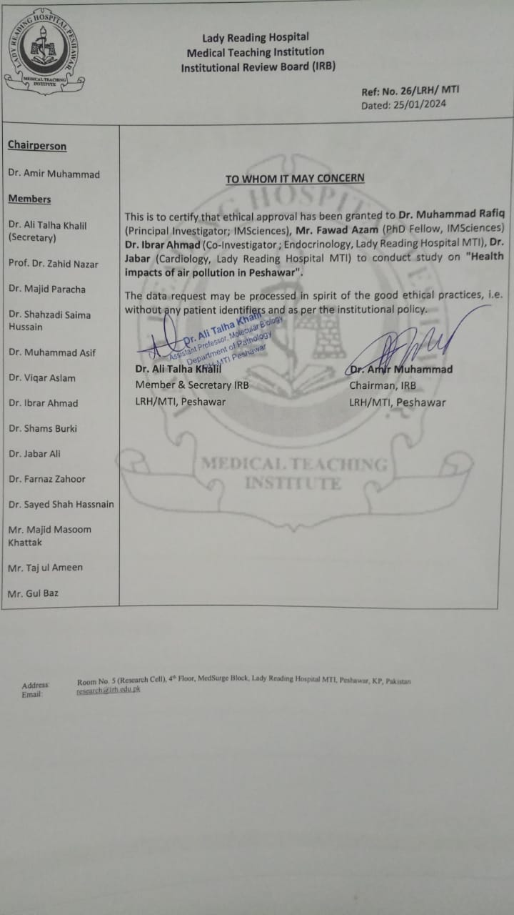

# Annexure-6

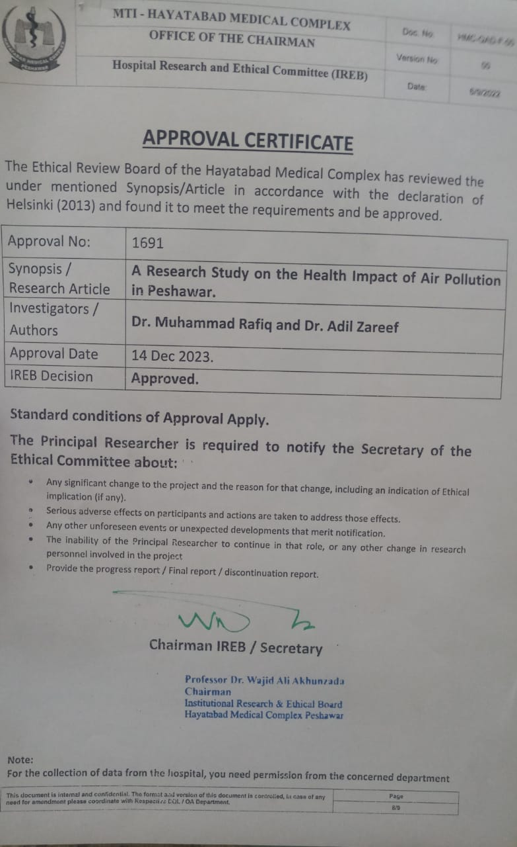

1. See <https://www.who.int/data/gho/data/indicators/indicator-details/GHO/mbd-aap-ambient-air-pollution-attributable-dalys>
2. Brauer et al., 2012; GBD 2019 Risk Factors Collaborators*, 2020; Han et al., 2019; Zhang et al., 2022).
3. GBD 2019 Risk Factors Collaborators*, 2020; Han et al., 2019; Health Effects Institute, 2022; Zhang et al., 2022)
4. Kirigia JM, Mburugu GN, Huka GS: The Indirect Cost of Disability Adjusted Life Years Lost among the Elderly in Kenya. Int Arch Med 2017; 10(213).
5. https://www.who.int/data/gho/data/indicators/indicator-details/GHO/ambient-air-pollution-attributable-dalys-(per-100-000-population)
6. **Anthracosis, also known as coal workers' pneumoconiosis (CWP) or black lung disease, is a form of pneumoconiosis caused by the inhalation of coal dust.**
7. According to this study,

   “This study indicates that ambient air pollution exposure may contribute to increased risk of incidence and progressions of Type 2Diabetes, but to diverse extents for different progressions”.
8. https://www.who.int/data/gho/data/indicators/indicator-details/GHO/ambient-air-pollution-attributable-dalys-(per-100-000-population)
9. This is a similar concept to GDP.
10. https://documents.worldbank.org/curated/en/897001552661768639/pdf/135335-PN-P163618-PUBLIC-15-3-2019-16-1-53-PakEnvironmentalSustainabilityFinal.pdf
11. 1 USD = 280 PKR
12. This is roughly 2.19 percent of the Gross State Product (GSP) of District Peshawar ( [*"GDP OF KHYBER PAKHTUNKHWA DISTRICTS"*](https://kpbos.gov.pk/assets/docs/reports/NTL-PolicyBrief-Aug-1.pdf)*(PDF). kpbos.gov.pk.*
13. (Rafiq & Luqman, 2022; Rafiq, & Khan,2014)
14. Willingness to pay (WTP) is the maximum amount of money a customer is willing to pay for a product or service. It is calculated in environmental and health studies to assess the welfare impact. Whereas Human capital approach assess the welfare gain and losses as number of years lost/gains multiplied with the average wages/GDP.
15. 43 billion PKR/ 4.7 million population of District Peshawar.
16. The Integrated Disease Surveillance and Response (IDSR) framework makes surveillance and laboratory data more usable, helping public health managers and decision-makers improve detection and response to the leading causes of illness, death, and disability in African countries.