**Policy Brief**

**Targeted Interventions for Improving Air Quality Management in Peshawar: Using International Best Approaches to Reduce Air Pollution**

**1 Introduction**

In 2022, the State of Air Pollution in Peshawar report was launched; it described the trends in air quality, along with reasons for gradual deterioration and proposed interventions for mitigating high levels or particulate matter in the Peshawar region. As a policy goal, controlling air pollution will help to serve the achievement of sustainable development goals in Khyber Pakhtunkhwa. This Policy brief has been designed in continuity of the report and aims to serve as a guide to policy-makers and administration for prioritization of high-impact interventions as well as low-cost solutions. Furthermore, as an addition to last year’s report, the brief describes the unique ‘air-shed’ dynamics of the Peshawar region, which influence transport of pollution and air quality levels in the city. The brief takes into account the governance and budgetary limitations that are currently facing provincial governments in the country, and proposes only the most suited interventions that can be operationalized in the short-term. Lastly, it explores some examples from across the region and the globe, which can be useful for policymakers for future planning.

The State of Air Pollution in Peshawar report showed that the highest contribution among sources of pollution comes from the Transport sector (58.46%), followed by presence of high amounts of Dust particulate (17.67%); other sources included, in descending order, Domestic burning activity, Industry, Waste-burning, and Commercial establishments such as restaurants.[1] Based on these findings the report proposed the following interventions: (1) Expanding monitoring capacity [to increase public awareness and enable precautionary measures]; (2) Encouraging higher Public Transport usage, [through better accessibility, incentives, and public communications]; (3) Developing alternative and/or subsidized heating methods [to curtail wood-burning]; (4) Behavioral change campaigning [publicizing affordability and eco-friendliness of alternative transport and fuel options]; (5) Aligning Urban Forestation [for Air Quality management]; and (6) Increasing role of civil society, universities, startups and private sector [by streamlining efforts and creating forums for collaboration].[2]

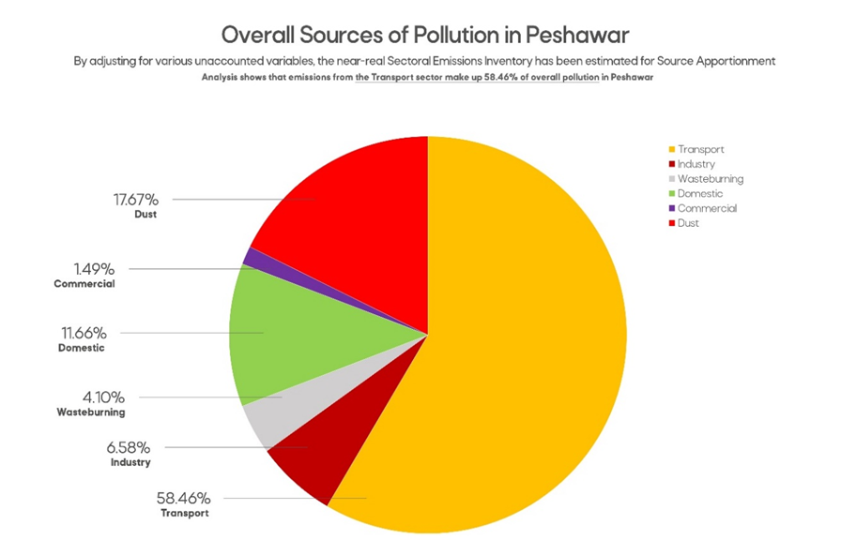This Policy brief, as mentioned above, focuses on operationalization of these recommendations, focusing on the two biggest contributing sources, along with continued evidence generation. By focusing on these two sources, it is assumed that highest net social and environmental benefits can be gained over the short-term. As Peshawar region is valley, it also has a unique geography and meteorology, which must be taken into account for air quality management, particularly to manage impact of regional and long-range transport of particulate matter, which influences pollution levels in the city.

**Figure 1** Source apportionment of Air Pollution in Peshawar

**2.1 Understanding Regional Dynamics**

The Peshawar region holds the distinction of being the most densely populated area west of the Indus river. A recent study by the World Bank recognized North-western and Central Indus plains as a single ‘Air-shed’ – considering similar climatology of this region and air-quality trends.[3] Furthermore, the increasing elevation, which bounds the Peshawar valley in the west, also acts as another factor that influences the volume of pollutants in the region at any given point. Movement of air ‘parcels’ from any direction as well as wind speed further effects air-quality.

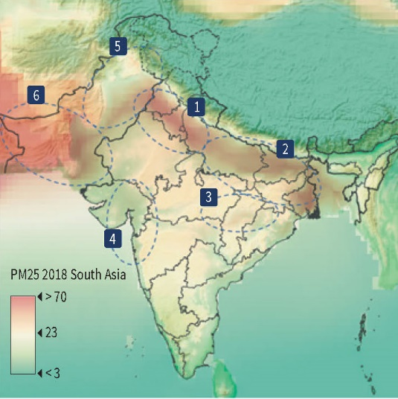

**Figure 2** Air-sheds in South Asia, identified by the World Bank (No. 5 is the air-shed covering the Peshawar region)

Policy-makers need to develop a regional understanding of pollution in Peshawar in order to effectively address it, as movement of particulate, such as dust from arid regions around the city. One of the methods to do this is to conduct analysis of air parcel trajectories, which can be done through tools such as NOAA’s HYSPLIT[4] model which simulates movement and dispersion of substances. A similar analysis had also been used in the ‘R-SMOG’ report[5] that delineated the cross-border movement of particulate from crop waste-burning in Punjab. To further illustrate this, a short-term HYSPLIT analysis was conducted for the Post-monsoon and Winter seasons of 2021 and 2022.

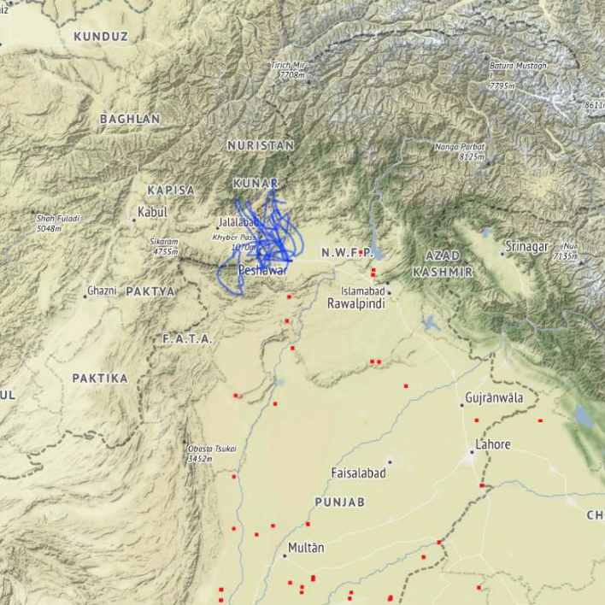**Figure 3**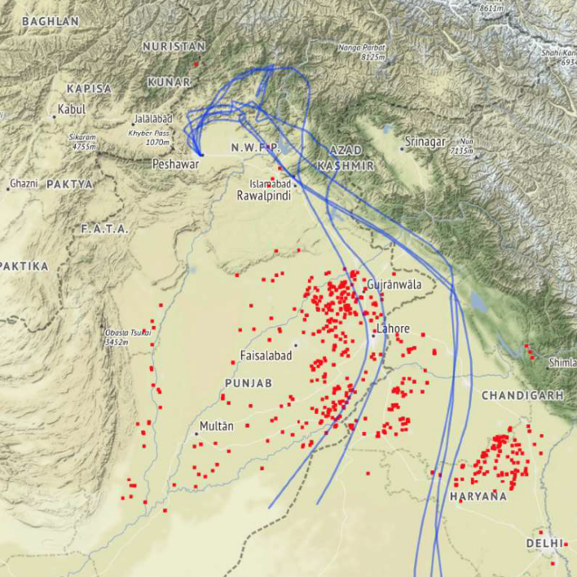 The movement of ‘air parcels’ changes considerably between Post-Monsoon (left) and Winter (right).

Using the HYSPLIT model for Peshawar, it was observed that Pollutants travel long-distance as well as become regionally stagnant. Furthermore, while data is currently limited, it was observed that during the high pollution months of November and December, air parcels were more likely to be originating from the arid regions (West or North-west) or stayed within the radius of the Peshawar valley. These wind movements are due to the ‘Western depressions’ phenomenon.

**Figure 4** Based on HYSPLIT Model for Air trajectory, it can be seen that Westerly wind is dominant

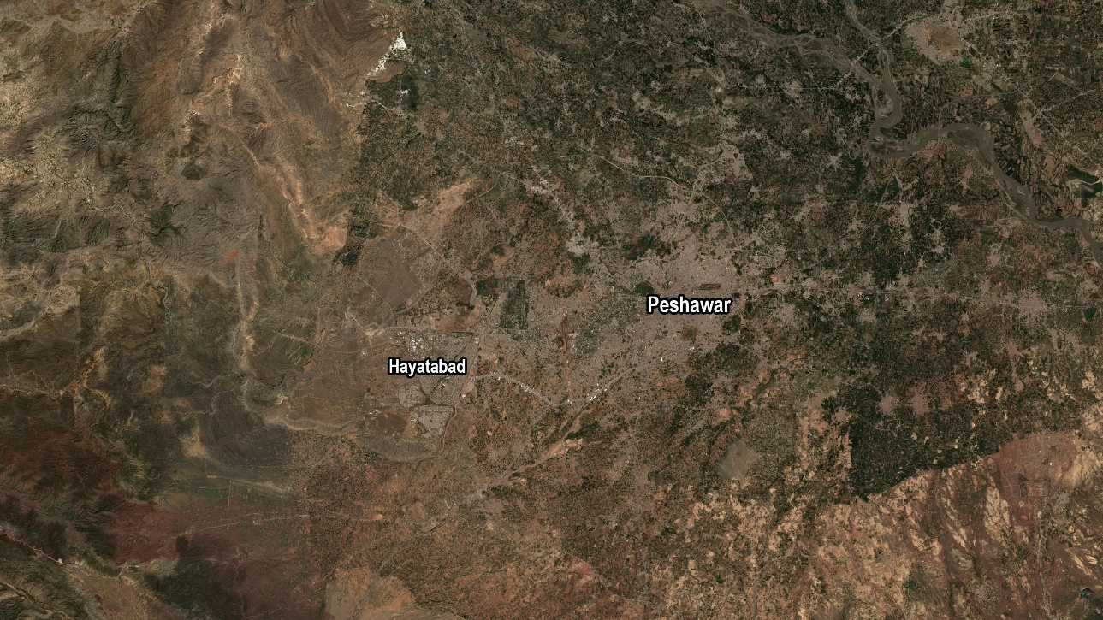For the data-set used, it was common for particulate from western direction to swoop into the city, while on non-dominant days particulate became stagnant over the city due to slower wind speeds and, likely, temperature inversion. Furthermore, a geographical analysis of the region reveals that the western side of Peshawar, from Jamrud onwards is arid and bare of any vegetation, even after Monsoon rainfalls, which makes Peshawar region susceptible to transport of dust particulate in the dry, winter months, carried by westerly winds.

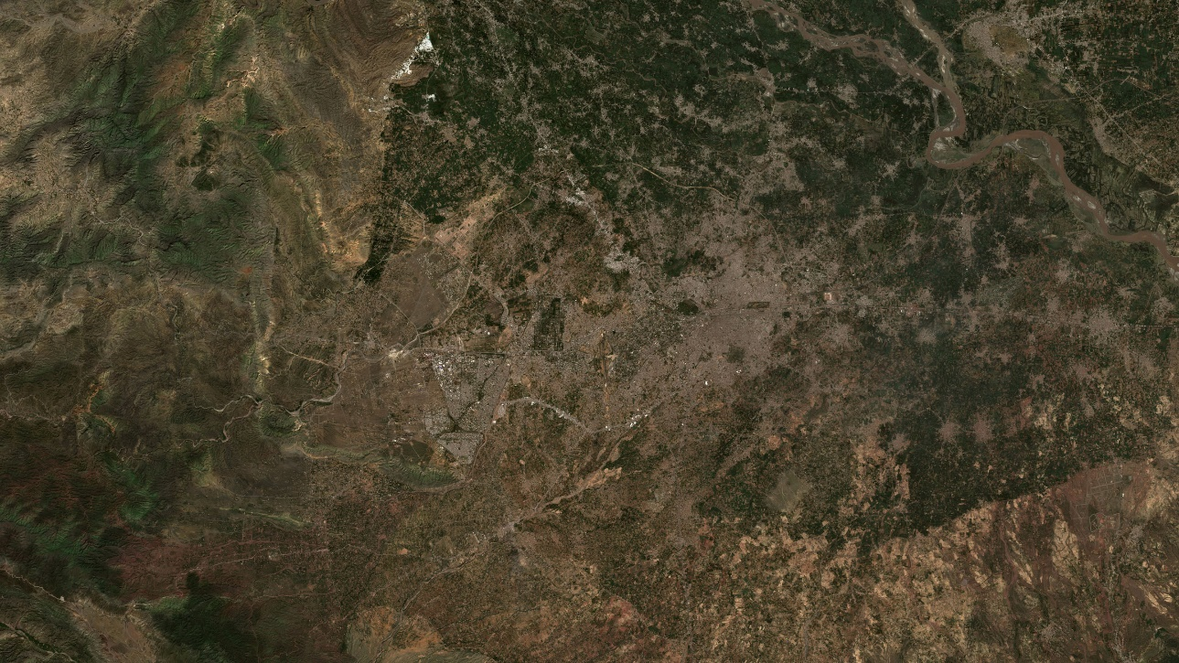

**Figure 5** Differences in vegetation around Peshawar during Pre-Monsoon (May) and Late-Monsoon (September) in 2022.

**2.2 Regional Afforestation & Other Measures for curtailing Dust Particulate**

The increased levels of dust particulate in Peshawar over the past few years is quite visible even to the naked eye. The significant increase is both due to the expansion of the city towards its western zone as well as more construction activity; while dust is transported into the city during the dry season, certain activities can also further aggravate concentrations if these events take place in combination. Based on the findings above, it is clear that effective curtailment of dust aerosol can help improve air quality in the city. A study conducted by the UK’s DEFRA[6] reported that “reductions in concentration (>20%) could be achieved using vegetation to enhance deposition over a substantial area.”[7] While the regions in UK are already considerably green, it can be assumed that an equal or greater benefit could be gained in the Peshawar region.

Dust particulate originating from natural phenomenon cannot be curtailed; however, its transport into cities is aggravated due to denudation of existing green cover. Therefore, recovering lost green cover and afforestation can act as barriers to excessive inward movement of dust particulate into Peshawar. As shown in the satellite imagery above, areas for such afforestation activities can also be easily identified, especially at the western extents of Peshawar district, as well as in neighboring (now merged) Khyber district.

The Khyber Pakhtunkhwa government had already approved afforestation and plantation schemes for Peshawar, however, these require allocation of sufficient funds as well as proper planning for execution, in order to earn the right benefits. Planning should take into account geography, wind trajectories, and indigenous species that can result in greater deposition of particulate.

In addition to this, in was also observed in the State of Air Pollution in Peshawar report that construction dust has become an added burden for the city; excessive dust aerosol was observed during the Peshawar BRT construction period. This suggests that effective dust controlling mechanisms and its enforcement is lacking. Several construction projects can be publicly beneficial, including BRT systems, but can also increase pollution levels during the construction phase. Beyond this, dust from roads, curbsides, open surfaces, and empty plots can also become re-suspended in the air. Currently, the practice of sprinkling water on roadsides is performed by relevant municipal authorities, to increase moisture content for road dust control. However, better ‘misting’ technologies need to be adopted, along with permanently covering any exposed surfaces, such as with gravel. As dust forms nearly 18 percent of the pollution, curtailing transport and re-suspension can enable reductions in pollution levels within the next 3-5 years.

**3.1 Emissions Aware Traffic Management for Quick Wins**

The Transport sector has been identified as the largest source of pollution in all major cities in Pakistan. In Peshawar, due to limited power sector emissions, it’s share is proportionally even higher, at nearly 3/5ths of all air pollutants. Year-on-year increases in the vehicle population has also translated into a linear increase in emissions. Furthermore, the city’s traffic management strategy does not inculcate measures for emissions reductions, and like other cities, provides increased access to vehicles during peak hours, and thereby inducing more demand for road-use overtime. While traffic management is complex, policies such as road-rationing and low-emission zones employed in other parts of the world have shown immediate benefits in the short-term. The reductions in emissions also provide the governments to use the time for developing alternative or cleaner modes of transport, which can further build upon gains, in the medium term.

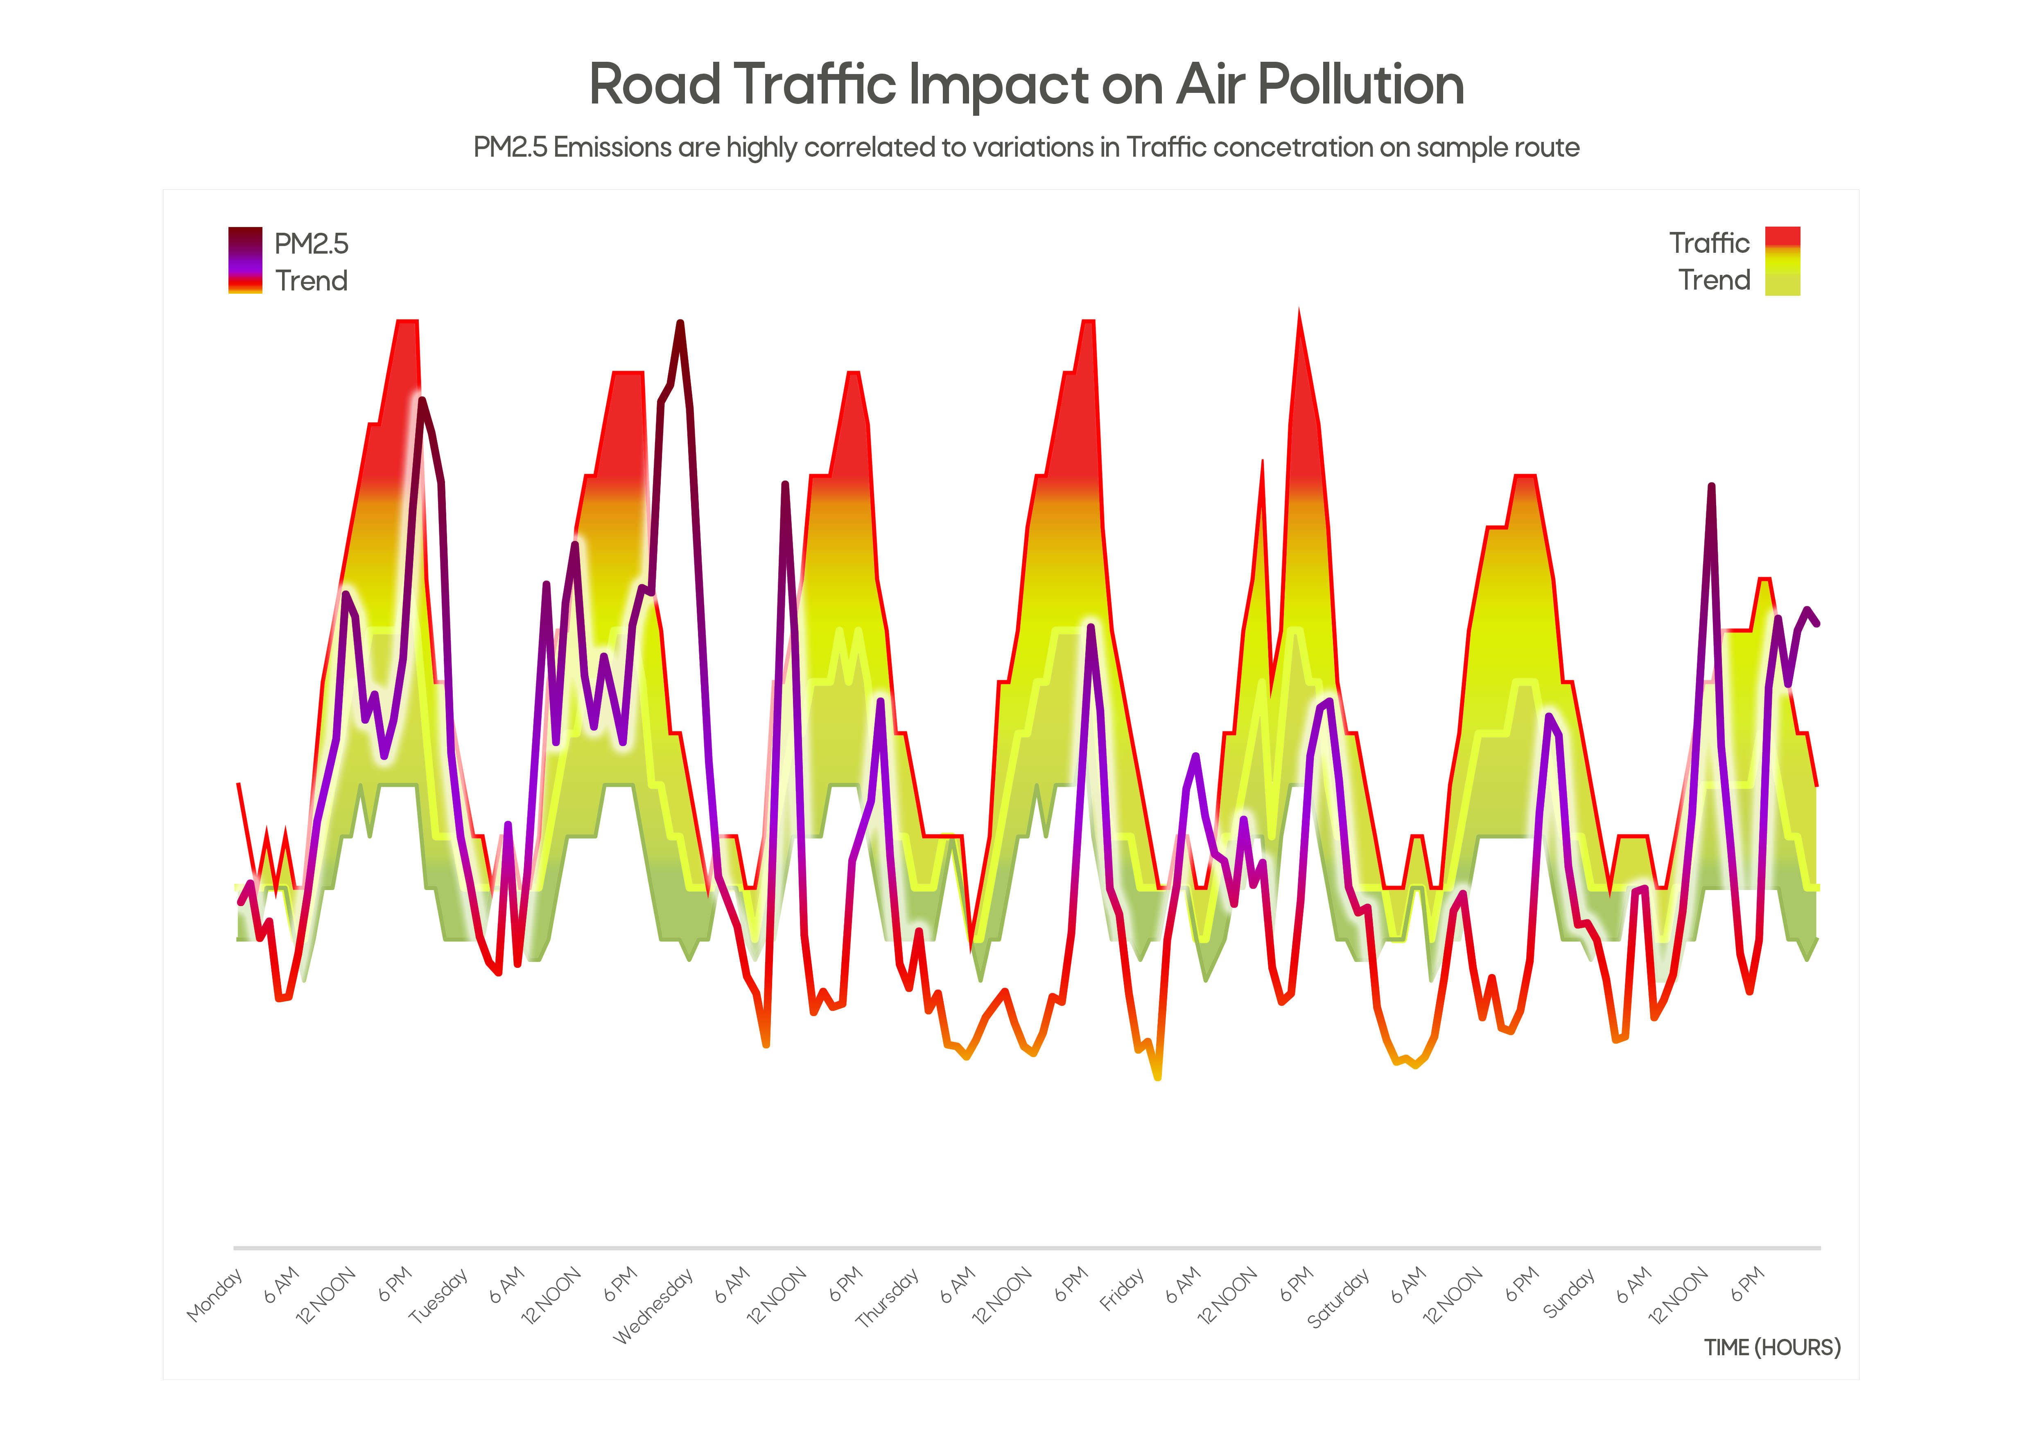

**Figure 6** Analysis of Traffic congestion on the GT Road and PM2.5 levels show close correlation

While dust particulate levels may depend on factors beyond administrative control of Peshawar, emissions from traffic – which is the largest source – originate within the city (Fig 6), and without curtailing these emissions, significant improvements in air quality are not possible. This is particularly important for the dry post-monsoon and winter periods, when the burden on transport emissions increases due to wind stagnation and inversion, and is worsened by westerly movements of dusty air.

**Figure 7** High concentrations of Nitrogen Dioxide (NO2), emitted from Vehicular traffic, observed on major roads in the core of Peshawar city

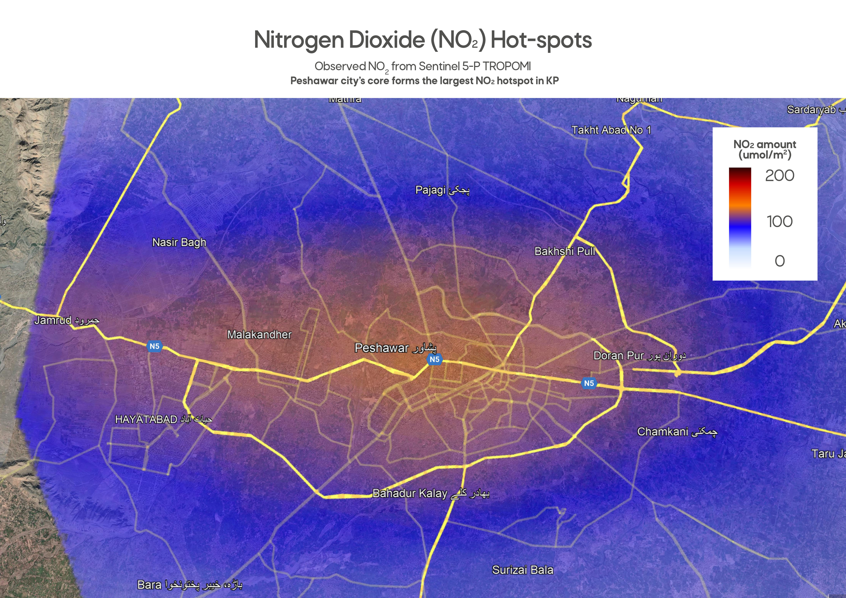

Multiple cities around the world, in countries with comparable development contexts, have experimented with two major traffic management strategies, for both reducing emissions and congestion – due to the high economic and social impacts of both.

‘Vehicle rationing’ is strategy that requires little investment, but high effort in terms of administrative enforcement and compliance. An example of vehicle rationing is the “odd-even” allowance of private vehicles on the road, based on the last digit of their registration plate numbers (i.e. it ends with odd or even number). This approach was recently used in India’s pollution prone capital, particularly during the high pollution months. It has also been used in other cities, such as Beijing and Buenos Aires – where similar high levels of congestion and emissions used to be a major problem. Vehicle rationing has also faced criticism in countries where the government did not provide effective alternatives or enforcement was week. However, a recent study conducted showed positive outcomes of the Odd-even strategy in Delhi. When the strategy was enforced, the city saw reductions in peak pollution levels by 10-13 percent in various parts of the city, even though enforcement was weak.[8] A further survey showed, that while there was considerable violations of the policy by private car owners, there was also an increase in use Public transport buses, Metro, and car-pooling, as citizens found 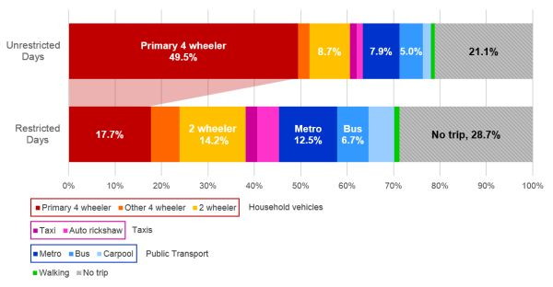ways to carry out their regular commutes or simple reduced unnecessary vehicle use.[9]

**Figure 8** Survey results for commuting methods used in Delhi during the 'Odd-even' system (IGC Blog)

Another study conducted to review Ecuador’s ‘Pico y Placa’ program found that it reduced Carbon Monoxide (CO) levels by 9-11 percent during the enforcement period.[10] The World Bank’s report ‘Cleaning Pakistan’s Air’ reported that there was a correlation between CO and PM2.5 levels in Pakistani cities, as traffic emissions were the largest source in urban areas.[11] As economic contexts of countries improved, such vehicle rationing policies have now been gradually replaced with ‘Congestion charging’ that permits private vehicles to use the roads, however, for an additional tax, accounting for the congestion and emissions.

Another strategy that is being adopted, in more advanced economies, is the creation of ‘Low-emission zones’ (LEZs) in parts of cities. This strategy is primarily focused on health impacts of emissions, as it allows clean-energy vehicles to enter and move through the zones, but restricts polluting vehicles such as those which use Diesel or low-quality Gasoline. Low-emission zones are implemented in areas, where congestion may not be necessarily a recurrent problem, but the health burden could be high, such as in areas of the city where Hospitals, Schools, or Public parks are located.

LEZs have been adopted across the world, especially, to curtail emissions in the cores of large cities. In London, for example, the LEZ has now expanded to most of the metropolitan area, and congestion charges are applied in a broader ‘Congestion-charge zone’, while an Ultra LEZ has been implemented since 2019 in the central districts of the city.[12] Similarly, LEZ was implemented in Hong Kong, with the quality of fuel used in vehicles as the deciding factor. Hong Kong allowed vehicles using Euro-4 and above fuel quality and vehicle emissions standard to operate through the zone, which was an indirect incentive to replace old vehicle fleet and only use cleaner fuels.[13]

In Pakistan, it could be said that a rudimentary form of LEZ implementation also occurs, whereby city or town administrations restrict the movement of heavy diesel-run vehicles for limited duration during day-times. Such as heavy vehicles are only permitted to enter housing schemes after midnight. However, the efficacy of this strategy on emissions is not known, and it has largely been adopted as an arbitrary measure to reduce congestion and improve road safety during day-time and evening peak hours. Such a strategy could be useful as a starting point, and if it adequately accounts of pollution trends, and area dynamics. Implementing LEZs also requires issuance of Vehicle emissions certifications, which allow easy automation for accessibility of vehicles into these zones. This would entail establishing a Vehicle Inspection regime, which is enforced on all vehicles at regular intervals, such as renewal of Excise duties.

**3.2 Moving towards Green Mobility for Long-term Emissions Reductions**

It is increasingly being accepted that the future of mobility will be Electric vehicles, Non-motorized transport, and clean Mass-transit. This has become particularly popular as countries race to establish Net-Zero targets and deliver on SDG commitments. A major push has been seen under the World Bank and GIZ led ‘Sustainable Mobility 4 All’ initiative, currently working in several cities around the world.[14] Another reason is the increasing supply of cheaper Electric and Clean-energy vehicles, as costs of battery manufacturing continue to reduce. In the case of Peshawar, such a future must also be envisioned and planned, through a “Green Mobility” Policy.

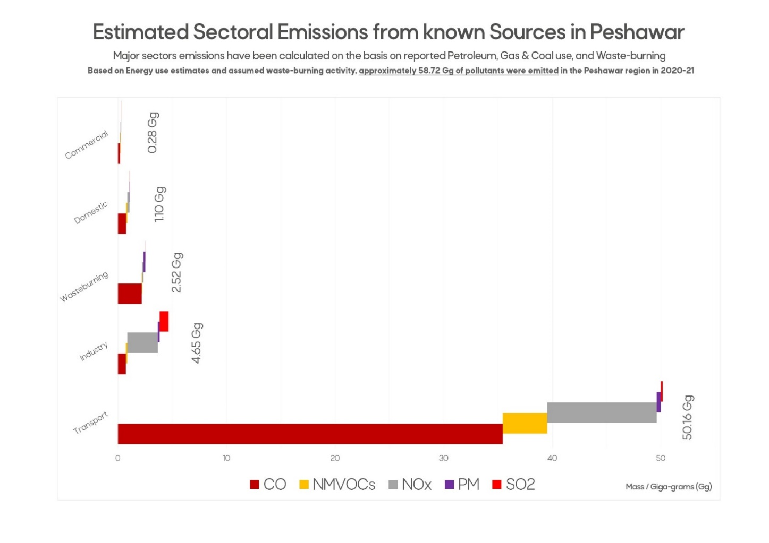Green mobility can be defined as an approach to “reduce the environmental impact of mobility in terms of greenhouse gas (GHG) emissions, air pollution, and noise.”[15] By achieving these goals, several SDG targets can also be met, along with large net social, economic and environmental benefits. As shown in Peshawar’s emissions inventory, the transport sector emits harmful gases and particulate, and precursors to secondary pollutants.

**Figure 9** Emissions inventory of Peshawar for 2020-21

Green mobility focuses on deploying electric motorbikes, cars, and buses, which completely removes all tail-pipe emissions. As Khyber Pakhtunkhwa is the only province in Pakistan, which receives maximum proportion of electricity through clean energy, specifically Hydro-power, it can also be assumed that Vehicle charging sources will also have minimal emissions of air pollutants. Additionally, the lower energy costs from clean sources such as Hydro, Wind and Solar, means that Green mobility options will be significantly cheaper in terms of kilometers driven. The vehicle population of Peshawar suggests that there continues to be significant demand for Two-wheelers, which is where encouraging use and manufacture of electric motorbikes can also converge to reduce pollution and provide economic opportunities. Over 8 years, the population of Two-wheelers increased by 168.8 percent – suggesting a complete doubling of population over the last decade. Additionally, a significant number 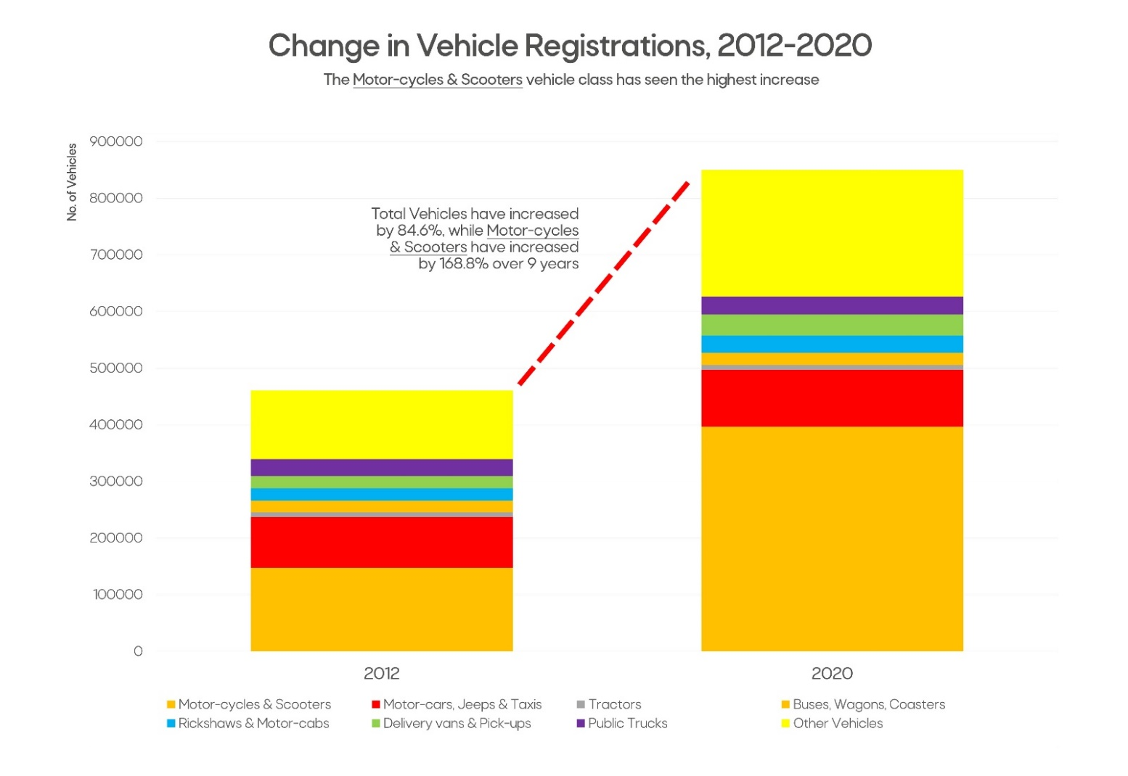of vehicles is registered outside Peshawar, and their emissions cannot be accounted for accurately.

**Figure 10** Between 2012 and 2020, the registered no. of Two-wheelers increased by 168.8 percent

Lastly, deploying green mobility at the regional level also requires the creation of an efficient charging infrastructure. For this, it is recommended that the policy focuses on Mass-transit, along with replacing conventional Two and Three wheelers to electric, for the initial phase, as charging mechanisms such as battery-exchanges are have found more success in developing country contexts. In order to fully benefit, it is recommended that feasibility be conducted for Electric Vehicle charging infrastructure, along with developing a Green Mobility Policy.

**4 Intervention Options**

Based on the discussion above, several key takeaways can be gathered; however, keeping in mind the limitations mentioned earlier, the highlighted recommendations for interventions have been grouped together into two categories based on the stakeholders involved: (i) Project Oriented, and (ii) Administrative Actions. Furthermore, these major recommendations are scored on the basis of their Implementation potential, and assumed Environmental and Social benefits (scoring sheet attached as Annex).

**Project Oriented**

1. Targeted Afforestation in Western parts of Peshawar: Air Quality management needs to take into account Peshawar’s unique context, which includes movement of air inside the city as well as from outside, that can increase pollution levels. Afforestation projects should be implemented in specific areas at the western periphery of Peshawar district, as well as region around it, to curtail movement of dust aerosol during dry seasons.
2. Model Pedestrian Low-emissions Zone connecting with BRT: Increasing availability and usability of Non-motorised transport options, especially in urban quarters of the city, in conjunction with the Peshawar BRT. A public-friendly low-emissions zone will also incentivize higher BRT usage, reducing per capita emissions, while also create a ‘clean’ area in the city, reducing average urban emissions.
3. Initiate development of a Green Mobility Strategy: Planning for Long-term emissions reductions requires a Green Mobility Strategy for Peshawar, which prioritizes Public Mass-transit and Clean-energy for Private transport. Globally, city-level investments in infrastructure and incentives for Electric vehicles have significantly increased. Coupled with vehicle retirement, over the coming decades, many cities plan to replace current fleets with Clean-energy vehicles.

**Administrative Actions**

1. Traffic Management: Vehicle rationing: Among the Traffic management options discussed above, Vehicle Rationing during peak pollution periods was the most common strategy used by city-manager, to reduce average air pollution levels, and particularly avoid episodes of severely bad air quality. Several types of vehicle rationing exist, however, the one used within similar administrative constraints is the ‘Odd-even’ system, which uses license plates to monitor and curtail movements of private vehicles on alternative weekdays.

|  |  |  |  |  |  |  |  |  |
| --- | --- | --- | --- | --- | --- | --- | --- | --- |
| (Impacts) | | | (+) positive | (+) positive | (+) positive | (-) negative | (-) negative | **Total Score** |
| PM2.5 Reduction Potential | Carbon Offset Potential | Early Implementation | Financial Cost | Administrative Burden |
| 1 | Project Oriented | Targeted Afforestation in Western parts of Peshawar | 2 | 2 | 1 | 1 | 0 | 4 |
| Model Pedestrian Low-emissions Zone connecting with BRT | 3 | 2 | 3 | 2 | 1 | 5 |
| Initiate Green Transportation Strategy | 4 | 4 | 1 | 3 | 0 | **6** |
| 2 | Administrative Actions | Traffic Management: Vehicle rationing | 5 | 5 | 3 | 2 | 5 | 6 |
| Traffic Management: Limiting Diesel Vehicle access | 4 | 4 | 3 | 1 | 3 | **7** |
| Implementing Advanced Construction Dust controls | 2 | 1 | 3 | 1 | 1 | 6 |
| Implementing Clean Fuel (Euro-5) in Peshawar District | 3 | 1 | 3 | 2 | 1 | 4 |

1. Traffic Management: Limiting Diesel Vehicle access: An alternative traffic management option it to use ‘Emissions aware’ policing, and disallowing access by heavy diesel vehicles into the city for set periods of time. Accumulation of winter smog is associated with cooler air, while air quality can also be forecasted; during expected periods of peak pollution, such diesel-run transport can be forced to shut down, thereby limiting average emissions from reaching hazardous levels.
2. Implementing Advanced Construction Dust controls: Presence of construction dust has been repeatedly been highlighted in observations and research. However, currently, very basic controls are implemented. Enforcement is also low, even for large infrastructure projects. Advanced techniques such as usage of ‘Misting canons’ and larger barriers need to be introduced as mandatory for construction activities, especially during the dry post-monsoon period, when the city is already susceptible to increased inward movement of dust.
3. Implementing Clean Fuel (Euro-5) in Peshawar District: Poor fuel quality has been a major cause of higher Particulate emissions from Diesel run vehicles. As an intervention of last resort, making cleaner fuel (i.e. Euro-5 compliant or better HSD) available at fuel stations during peak pollution months can also curtain high particulate levels. Euro-5 compliant HSD currently has to be imported and may require special logistical arrangements to transport to Peshawar.

The above described interventions have been scored on the basis of the criteria mentioned, and highest feasible options are highlighted:

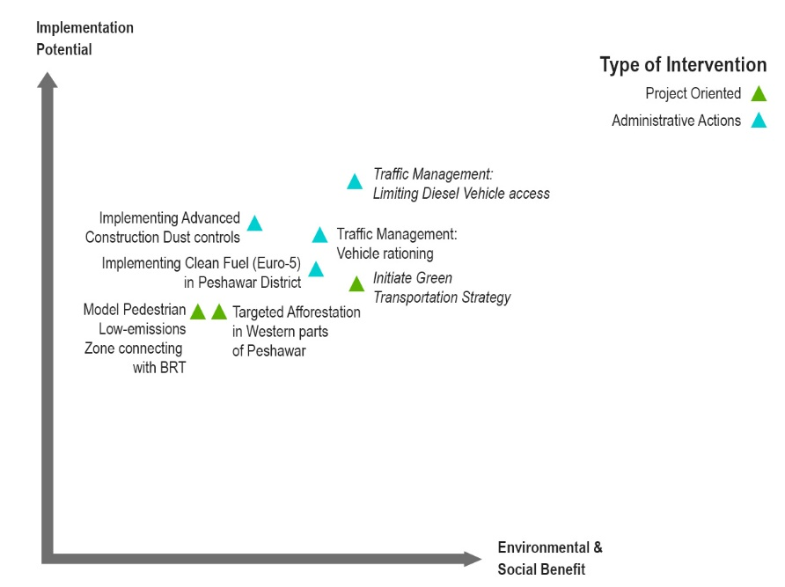

Figure 11 Intervention options ranked by feasibility

**5 Discussion**

The evidence finds that serveral options are available which can be operationalized to manage air quality in Peshawar. However, short-term options are few, which limit the full-potential of benefits that may be generated in the long-term. Over the coming months, the two most feasible options are to implement (i) a Green Transportation Strategy for Peshawar, and (ii) Limiting Diesel Vehicle access based on pollution forecasts. Both options can act to not only provide air pollution reductions, but can also reduce carbon emissions, as they are meant to increase acceptabilty of alternative, cleaner modes of transport, and increase efficiency of exisiting modes of transport. As the latter does not require additional financial investment, both can be implemented during the same period as well, allowing for a larger offset compared to implementing only one.

During the course of evidence gathering for the State of Air Pollution report and this Policy paper, it has been keenly observed that, both locally and internationally, Urban transit and fuel-quality are among the most siginificant factors impacting air quality and its management. Meteorology and Air-shed dynamics are not in control of administrators and policy-makers, however, managing major sources of emissions has resulted in cleaning air in several developing countries, most notably in China, in the last 10 years. Currently, similar interventions are also being operationalised in India.

Beyond the scope of this paper, the ‘China model’ offers several learnings, particularly in terms of urban air quality management, such as in the capital, Beijing. From 2013 onwards, the Chinese central government, and local government in Beijing began implementing a series of plans aimed at reducing particulate emissions linked to motor vehicles. The *Action Plan for Air Pollution Prevention and Control* was implemented throughout the Beijing-Tianjin-Hebei region, targeting 25 percent reducitons in pollution by 2017.[16] This plan was able to achieve this milestone by 2017, as a result of strong coordinated response and accountability.

In Beijing, specifically, a reforms programme was also implemented to modernize the Beijing Municipal Ecology and Environmental Bureau (BEE), which is tasked with managing air quality in the region. Beyond the ‘action plan’, the Beijing municipality implemented several interventions. For motor-vehicles, an early adoption of ‘China-4’ (Euro-4 equivalent) emissions standard was ordered, and ‘China-5’ (Euro-5 equivalent) standards were enforced before the national roll-out. Separately, in 4 years, approximately 20 million old vehicles of various kinds were retired from the roads of the city, and incentives were given to public to adopt public transport for daily commutes. More recently, Beijing has also rolled out the *Beijing Blue Sky Action Plan* that made regulaitons even stricter and began targetting sepcific sectoral interventions for emissions reductions.[17]

In India, the capital city New Delhi has been the focus of government interventions, especially in relation to transportation and energy use. Use of lower grade petroleum and diesel engine vehicles was banned in the past “smog season” as an emergency measure to reduce peak pollution.[18] A deadline for 2026 has also been suggested for a complete ban on plying of diesel-run Auto-rickshaws in the capital, likely to be replaced with Electric Three-wheelers.[19] The initiatives in New Delhi are somewhat modelled after the success of Beijing. As Beijing implemented ‘China V’ diesel emissions standards, so is New Delhi implementing ‘Bharat Standard V’ for diesel vehicles. At the start of Bejing’s action plan diesel contributed up to 70 percent of all NOx emissions and road-side PM2.5.[20] In Pakistan’s case, although the Federal Petroleum division has notified Euro V standard for diesel, the higher quality fuel is not available in most parts of the country, as the refines produce lower quality fuels, while engine standards for manufactured and imported cars have not been improved. To resolve this issue, cleaner diesel can be provided thorugh Oil Marketing Companies and their retail outlets in Smog prone large cities – as has been done in Beijing and New Delhi.

Besides reducing the number of diesel-run vehicles, proposals for expanding public transport, as well as its electrification are likely to be implemented, in order to further reduce transport emissions. Among the ‘greening’ initiatives are plans to introduce 1,600 new electric buses, 900 EV charging points, and a “Mohalla Bus” service to resolve Delhi’s public transport’s last-mile connectivity gaps.[21] Green mobility solutions have also shown significant impact in other cities around the world, with metropolitan transportaion strategies taking climate and air emissions impact of implemented solutions. Lastly, both in China and India, government financing facilities, such as lower cost leases, tax breaks, and lower tolls have been provided to retire older vehicles in major urban zones, and private entrepreneurs have been incentivised to set-up related enterprises such as EV ride-sharing and E-bike rental services.

Overall, Chinese cities have shown the greatest clean air transformation in recent history. These rapid reductions have also meant that cities in Pakistan and India that were ranked lower earlier in terms of PM2.5 pollution now feature in the top 10. Using these learnings, and governance strategies, it is very much possible for cities to drastically reduce air pollution, given strong government interest and evidence-backed policies. As highlighted earlier, Peshawar can begin taking such steps, and very soon accelerate inteventions for achieving healthy air quality.

1. *State of Air Pollution in Peshawar.* SEED. 2022.
2. Ibid
3. <https://fasps.denr.gov.ph/index.php/resources/glossary-of-terms/air-shed>
4. The Hybrid Single-Particle Lagrangian Integrated Trajectory model (HYSPLIT), developed by NOAA’s Air Resources Laboratory, is one of the most widely used models for atmospheric trajectory and dispersion calculations. NOAA is the abbreviation for National Oceanic & Atmospheric Administration (USA).
5. Remote-sensing for Spatio-temporal Mapping of Smog in Punjab and Identification of Underlying causes using GIS techniques.” 2018. Food and Agriculture Organization of the United Nations (FAO).
6. <https://uk-air.defra.gov.uk/library/reports.php?report_id=966>
7. Ibid
8. <https://epic.uchicago.edu/insights/yes-delhi-it-worked/>
9. <https://www.theigc.org/blogs/driving-delhi-impact-driving-restrictions-driver-behaviour>
10. Carrillo, Paul E. and Malik, Arun S. and Yoo, Yiseon, Driving Restrictions that Work? Quito's Pico y Placa Program (September 24, 2014). < <https://ssrn.com/abstract=2240327>>
11. “Sanchez-Triana, Ernesto; Enriquez, Santiago; Afzal, Javaid; Nakagawa, Akiko; Khan, Asif Shuja. 2014. Cleaning Pakistan's Air : Policy Options to Address the Cost of Outdoor Air Pollution. World Bank.
12. <https://tfl.gov.uk/modes/driving/low-emission-zone>
13. <https://www.legco.gov.hk/research-publications/english/essentials-1415ise09-low-emission-zone.htm>
14. <https://www.sum4all.org/>
15. Ibid
16. <https://policy.asiapacificenergy.org/sites/default/files/Air%20Pollution%20Prevention%20and%20Control%20Action%20Plan%20%28EN%29.pdf>
17. <https://www.iea.org/policies/8508-three-year-action-plan-for-cleaner-air-also-called-the-blue-sky-war>
18. <https://economictimes.indiatimes.com/news/india/centres-air-quality-panel-bans-plying-of-diesel-lmvs-in-delhi-ncr-as-air-quality-dips-to-severe/articleshow/95281749.cms?from=mdr>
19. <https://auto.hindustantimes.com/auto/news/diesel-autos-to-be-phased-out-in-delhi-ncr-by-2026-says-air-pollution-policy-41657869198218.html>
20. <https://www.nrdc.org/bio/barbara-finamore/curbing-air-pollution-china-eliminate-dirty-diesel-fuel>
21. <https://www.downtoearth.org.in/news/air/delhi-public-transport-good-news-and-bad-news-88393>